**TOUCHOME: REVOLUTIONIZING HOME AUTOMATION WITH ENHANCED SAFETY AND SEAMLESS CONTROL**

**By:**

**Brettney Shane M. Francisco**

**Mc Laurenz G. Caracol**

**Rokc B. Balan**

**Nadzjar S. Arsad**

**Kenechi A. Plabrica**

**Michael H. Petallar**



**A Thesis Submitted in Partial Fulfillment of the**

**Requirements for the Degree of**

**BACHELOR OF SCIENCE IN COMPUTER ENGINEERING**

**COLLEGE OF ENGINEERING**

**SOUTHERN MINDANAO COLLEGES**

**PAGADIAN CITY**

**MAY 2024**

# CHAPTER 1

**Introduction**

## 1.1 Background of the Study

In the dynamic and ever-evolving realm of contemporary living, the advent of home automation represents a groundbreaking technological advancement. This innovative technology not only serves to augment convenience but also plays a pivotal role in bolstering the safety and efficiency of our daily lives (Josephine Wolff, 2021). As the researchers navigate through the complexities of the modern world, home automation emerges as a beacon of promise, promising a seamless integration of smart devices to create a more connected and intelligent living environment (Purtil, 2022).

However, the rapid pace of technological progress brings with it a set of challenges and limitations that have become increasingly apparent in existing home automation systems like; lacks a holistic and interconnected experience – different systems not working together smoothly, device compatibility issues, and complex setups make it difficult for users to have a seamless experience (Mennicken, et al., 2014); absence of real-time alerts – compromising the effectiveness of security measures (Gunge, 2016); suffer from limited accessibility because of distance – limiting usability and convenience whenever you’re not physically in the house (Manral, 2019); and high cost of ownership – currently modern home automation solutions pose financial challenges for many due to their lack of budget-friendliness (Brush, et al., 2011).

As the researchers embrace the potential benefits of home automation, it becomes imperative to address the evolving challenges to ensure that these systems meet the ever-growing expectations of users; integration of all systems, real-time notifications, demographic barriers, and keep pace with the dynamic landscape of technological innovation economically.

Through this system proposal, the researchers aspire to redefine the home automation landscape, providing users with a more integrated, responsive, and easily accessible smart home experience economically. By using words like "Integrated," researchers mean that fire and smoke sensors in the house can work together seamlessly to avoid fire accidents. "Responsive" suggests that these devices will react quickly to user commands as well as giving notifications, making interactions smoother. Additionally, researchers strive for “Accessibility”, meaning users can easily understand and use the smart home features online, eliminating demographic problems. And lastly, very “budget-friendly” that can let everyone to experience smart living. For that to be done, researchers will follow a systematic and comprehensive approach, beginning with an in-depth study to understand existing solutions, identify gaps, and learn from related studies. Continuous refinement based on user feedback ensures an advanced, user-friendly, and secure home automation system.

A thorough analysis of the identified challenges will guide the formulation of research solutions. And will incorporate methodologies such as assessments and prototype development to gather relevant data; creating a future where homes are not only smart but also cost efficient, safe, connected, and effortlessly controlled – ToucHome.

## 1.2 Problem Statement

Due to the rapid progression of technology, conventional home automation systems have faced challenges in meeting the changing needs and desires of homeowners (US National Intelligence Council, 2018). Laurinda B. Harman (2017) highlights the limited integration with new technologies such as sensors, further impeding the functionality and convenience of these systems. Moreover, the absence of real-time notifications in smart homes significantly compromises their reliability, as users are unable to promptly receive crucial updates or alerts regarding household events or emergencies. This hinders their confidence in its ability to effectively monitor and respond to critical situations in real-time. This unreliability poses a considerable drawback, impacting the overall functionality and trustworthiness of smart home technology within the household setting. Additionally, contemporary smart homes confront a significant limitation in accessibility, particularly when users are distant from their residences. Relying on physical accessibility, it restricts homeowners from overseeing and controlling smart home functionalities when away from their homes (Cheng et al., 2007). This reliance becomes a major hurdle, constraining users' capacity to interact with and manage the house, ultimately undermining the promise of continuous and seamless control outside their homes' confines. In the current market landscape, the affordability barrier of home automation systems significantly limits their accessibility, predominantly catering to a demographic of affluent individuals (Home Automation Market, 2024).

In response to these deficiencies, the imperative for innovation and advancement in smart home technology becomes increasingly evident. Addressing these shortcomings necessitates comprehensive changes of existing systems to align with the evolving needs and expectations of homeowners. To bring this home automation vision to life, researchers will integrate key tools in the system. The *DHT sensor library* will be used for integration of sensors – *fire and smoke sensors*, providing data for monitoring various aspects of the home environment. By implementing an online and user-friendly website, homeowners can remotely oversee and control smart home functionalities from anywhere. This solution aims to break the constraint imposed by physical accessibility, enabling users to interact with and manage smart home devices seamlessly, even when away from their homes. For notifications and alerts, researchers will utilize the *EmailSender library,* ensuring that users stay informed about important events. The *Ntpclient library* will grant access to precise time information via the internet, facilitating synchronized and time-sensitive actions within the smart home system. To enable internet connectivity and online accessibility, researchers will implement the *WiFi* and *Espasyncwebserver libraries*, ensuring a reliable and stable connection for seamless remote control and monitoring. Researchers have opted for economical alternatives like the *ESP32 microcontroller* over the pricier Raspberry Pi, facilitating wider adoption and cost-effectiveness. And incorporating *Nextion HMI 2.8” tft* touchscreen interface for display and user interactions. These tools collectively contribute to the robustness and functionality of the home automation system. Efforts to bridge these gaps will be instrumental in establishing smart homes as reliable, responsive, and indispensable components of modern living.

## 1.3 Objectives

In the pursuit of revolutionizing smart home management, ToucHome sets forth a series of objectives aimed at addressing prevalent challenges in sensors integration, real-time notifications, remote accessibility, and high cost ownership. These objectives form the cornerstone of ToucHome's mission to redefine the standards of convenience, reliability, and seamless control within modern home environments.

1. To analyze and optimize the online interface of ToucHome, ensuring uninterrupted access to home controls and monitoring from any location, transcending geographical limitations and enhancing remote accessibility for users.

2. To formulate cost-effective solutions by exploring innovative approaches and cost-effective alternatives to minimize financial barriers associated with home automation, ensuring ToucHome is accessible to a wider audience.

3. To design an integrated platform utilizing sensors that harmonizes disparate home systems, aiming to resolve the fragmented nature of current systems and ensure a cohesive user experience.

4. To develop a real-time notification system via email within the ToucHome platform, empowering homeowners with instant updates on significant household events, addressing the prevalent challenge of delayed notifications in existing smart home setups.

## 1.4 Scope

The research is motivated by the need to overcome specific challenges prevalent in current home automation systems; Inadequate connectivity hampers the smooth functioning of these systems, absence of real-time alerts creates delays in addressing critical situations, reliance on physical accessibility limits users' ability to manage their smart homes remotely, and high cost of ownership limits the home automations’ wider adaptation and usability. Recognizing these lapses, the study aims to bridge the existing gaps by focusing on key areas.

* **Fire and Smoke Sensors Integration** - ensuring that smoke and fire sensors in the home automation system work together seamlessly, providing accurate and synchronized data for effective monitoring.
* **Real-time notifications** - alerting homeowners promptly about events or changes in their homes, allowing for immediate awareness and timely actions.
* **Online Accessibility** - allowing users to monitor and control their smart homes online, regardless of their physical location. This feature enhances accessibility and widens the scope of home automation usage.
* **Low-Cost of Ownership -** ensuring financial sustainability for users of all budgets by minimizing installation, maintenance, and operational expenses. This includes using cost-effective components, optimizing energy efficiency, and minimizing maintenance needs.

## 1.5 Limitation

Within the scope of this research and the development of ToucHome as a solution for smart home management, certain limitations deserve consideration. These limitations, while not diminish the research's significance, outline crucial aspects that were not fully addressed or could impact the practical application and functionality of the developed system. Here are the following:

1. **Absence of Mobile Application:** ToucHome currently lacks a mobile application, meaning there isn't a specific app designed for use on mobile devices like smartphones or tablets.

2. **Online Dependency and Lack of Offline Accessibility:** Internet outages or poor connectivity may hinder the system's effectiveness, limiting homeowners' control.

**1.6 Significance of the Study**

The significance of this research lies in its substantial contributions to individuals, government entities, and the wider community. By revolutionizing smart home management, ToucHome directly impacts individuals by enhancing convenience, safety, and control within their living spaces. Its economically integrated platform and real-time notification system empower homeowners with seamless accessibility, ensuring timely updates and fostering peace of mind.

In terms of government interest, ToucHome's advancements align with the broader pursuit of smart city initiatives, offering insights into efficient home automation that can scale to larger urban contexts, potentially informing policies and infrastructure development.

Furthermore, this research doesn't solely benefit individuals or governments; it contributes to the community by promoting technological innovation that enhances quality of life, encourages sustainability practices, and potentially creates new economic opportunities within the burgeoning smart home industry.

Ultimately, ToucHome has the potential to positively impact people's daily lives, influence governance strategies, and foster a more technologically empowered and interconnected community.

## 1.7 Definition of Key Terms

**1.** **Agile Methodology:** An iterative approach to software development that prioritizes flexibility, collaboration, and continuous improvement. In ToucHome, the agile methodology is adopted to facilitate the iterative development process, allowing for rapid response to user feedback and evolving requirements.

**2.** **Budget-Friendly:** Refers to a product or service that is affordable and offers good value for money. In the context of ToucHome, it means the system is accessible to a wide range of consumers due to its affordable pricing structure.

**3. C++:** A high-level programming language commonly used for system software, game development, and other performance-critical applications. In ToucHome, C++ may be utilized for developing the backend logic and algorithms responsible for processing sensor data and managing system functionality.

**4. ESP32 Microcontroller**: A versatile microcontroller widely used in IoT (Internet of Things) applications due to its built-in Wi-Fi and Bluetooth capabilities. In ToucHome, the ESP32 microcontroller serves as the central processing unit, facilitating communication between various sensors and the user interface.

**5. Fire Sensor:** A device designed to detect the presence of flames or excessive heat, signaling a fire emergency. In ToucHome, fire sensors play a crucial role in identifying fire outbreaks promptly, allowing for quick response and evacuation measures.

**6. HTML:** A markup language used for creating and structuring web pages. In ToucHome, HTML is employed to design the user interface of the ToucHome website, providing users with a platform to access and interact with the home automation system.

**7. Home Automation:** The integration of technology within a residential setting to automate and control various functions such as lighting, temperature, security, and entertainment systems. In the context of ToucHome, it refers to the system's ability to automate and control household functions for enhanced convenience and efficiency.

**8. Live Notifications:** Real-time alerts or updates delivered to users to inform them of important events or changes. In ToucHome, live notifications are used to provide instant updates on safety-related issues, such as the detection of smoke or fire, ensuring timely action can be taken.

**9. Remote Control:** The ability to monitor and manage devices or systems from a distance, typically using a smartphone, computer, or other internet-connected devices. ToucHome offers remote control functionality, allowing users to access and control their home automation system from anywhere with an internet connection.

**10. Radar Graph:** A graphical representation of data that displays multiple variables on a two-dimensional chart, using radial lines to connect data points. In ToucHome, radar graphs may be used to visually represent the feedback received from users during the evaluation of the system, highlighting key aspects such as affordability, safety features, and user satisfaction.

**11. Smoke Sensor:** A device that detects the presence of smoke particles in the air, indicating a potential fire hazard. In ToucHome, smoke sensors are incorporated to enhance safety by providing early detection of smoke, enabling timely action to mitigate fire risks.

# CHAPTER 2

**REVIEW OF RELATED LITERATURE**

This chapter delves into the foundational research and key studies that underpin the evolution and advancements within the realm of home automation systems, specifically focusing on TouchHome. This comprehensive overview explores the integration of cutting-edge technologies, safety features, user-centric design principles, and the significance of seamless control in reshaping the landscape of modern residential living. Through an examination of prior studies, this review aims to illuminate TouchHome's innovative approach in addressing the multifaceted needs of homeowners, catering to efficiency, safety, and convenience within residential spaces.

## 2.1 IoT (Internet of Things)

The Internet of Things (IoT) represents a transformative concept in the realm of interconnected technologies. It encompasses a network of physical objects embedded with sensors, software, and connectivity features, enabling them to collect and exchange data. This interconnectedness facilitates a myriad of applications across various sectors, revolutionizing industries and everyday life.

1. *IoT Ecosystem and Connectivity:*

The IoT ecosystem comprises a vast network of connected devices, creating seamless communication and data sharing. As per Gubbi et al. (2013), this interconnectedness allows for real-time data transmission, fostering a web of devices capable of sharing information without human intervention. This interconnectedness has profoundly impacted industries, streamlining processes and optimizing resource utilization (Atzori et al., 2010).

1. *Ubiquitous Applications and Industry Impact:*

IoT applications span numerous domains, significantly impacting industries and societal facets. In healthcare, IoT facilitates remote patient monitoring, enhancing healthcare delivery (Islam et al., 2015). In smart cities, IoT infrastructure improves urban management through intelligent transportation systems and efficient resource allocation (Zanella et al., 2014). In manufacturing, IoT-driven automation enhances productivity and reduces operational costs (Hermann et al., 2016).

* 1. *Security and Privacy Concerns:*

However, the proliferation of IoT devices raises substantial concerns regarding security and privacy. According to Roman et al. (2013), interconnected devices present vulnerabilities susceptible to cyber threats and data breaches. Addressing these concerns remains crucial for fostering trust and ensuring the responsible implementation of IoT technologies.

* 1. *Advancements and Future Prospects:*

The evolution of IoT integrates advanced technologies like AI, machine learning, and edge computing (Bonomi et al., 2014). Future prospects envision a more interconnected and intelligent ecosystem where IoT devices collaborate seamlessly, making autonomous decisions based on real-time data analytics (Al-Fuqaha et al., 2015).

The Internet of Things serves as a transformative force, reshaping industries and societal interactions. As IoT technologies evolve, emphasis remains on harnessing its potential while addressing security and privacy challenges to ensure a safer and more connected future.

## 2.2 Integration of IoT in Home Automation

The integration of the Internet of Things (IoT) in home automation has revolutionized household functionalities, offering enhanced convenience and control over various aspects of domestic life.

*1. IoT in Smart Home Systems:*

IoT-enabled smart home systems leverage interconnected devices to automate and manage household functions. According to Atzori et al. (2010), these systems encompass a range of IoT-enabled devices such as smart thermostats, lighting controls, security cameras, and smart appliances that communicate and operate seamlessly to optimize comfort and efficiency.

*2. Enhanced Convenience and Comfort:*

IoT-based home automation provides unparalleled convenience by enabling remote access and control. Studies by Lee and Jang (2019) highlight the intuitive interfaces and user-friendly controls in smart home devices that facilitate easy management, allowing homeowners to adjust settings, monitor security, and manage energy consumption remotely.

1. *Energy Efficiency and Sustainability:*

Integration of IoT in home automation significantly contributes to energy efficiency. Research by Rashid et al. (2016) showcases IoT-enabled systems' ability to optimize energy usage by regulating heating, cooling, and lighting based on occupancy patterns and environmental conditions, thereby reducing energy waste and promoting sustainability.

1. *Security and Privacy Concerns:*

However, the proliferation of connected devices in smart homes raises concerns about cybersecurity and privacy. Studies like Roman et al. (2013) emphasize the vulnerabilities of interconnected devices, stressing the need for robust security measures to safeguard personal data and prevent unauthorized access to smart home networks.

In conclusion, the integration of IoT in home automation systems offers unparalleled convenience, energy efficiency, and improved quality of life. Yet, addressing security and privacy challenges remains crucial for the responsible adoption and sustainable growth of smart home technologies.

## 2.3 Microcontroller

Microcontrollers, as compact integrated circuits, play a pivotal role in various electronic devices, offering processing power, memory, and versatile input/output capabilities for specific task management.

1. *Functionality and Components of Microcontrollers:*

According to Mazidi, M. A., & Mazidi, J. G. (2016), microcontrollers serve as embedded systems that encompass a CPU, memory (RAM and ROM/Flash), input/output ports, and various peripheral interfaces on a single chip. They are designed for specific tasks, facilitating control and management within electronic devices.

1. *Applications in Electronic Devices:*

Microcontrollers find applications in diverse fields such as automation, robotics, consumer electronics, and automotive systems. Ayala (2013) emphasizes their use in controlling and managing tasks like sensor interfacing, data processing, motor control, and communication protocols within these applications.

1. *Advantages in Compact Design and Efficiency:*

One of the key advantages of microcontrollers lies in their compact design and efficiency. According to Yilmaz and Ersoy (2014), their integration of processing, memory, and I/O components on a single chip enables cost-effective and space-efficient solutions in various electronic systems.

1. *Role in IoT and Smart Systems:*

In the context of the Internet of Things (IoT) and smart systems, microcontrollers act as the fundamental control units. As stated by Yigang and Shuling (2017), they enable connectivity and control within IoT devices, facilitating communication and interaction among interconnected devices.

Microcontrollers represent integral components within electronic devices, providing processing power, memory, and versatile input/output functionalities. Their compact design and efficiency make them essential for a wide array of applications, from simple electronic gadgets to complex IoT systems.

## 2.4 ESP32

The ESP32 microcontroller has gained substantial attention for its versatility, wireless capabilities, and integration in diverse applications.

1. *Wireless Connectivity and IoT Integration:*

According to Hernandez and Garcia (2019), the ESP32 microcontroller's dual-core processor, alongside its built-in Wi-Fi and Bluetooth capabilities, positions it as a fundamental component for Internet of Things (IoT) applications. Its versatility in wireless communication contributes to its extensive use in IoT projects.

1. *Energy Efficiency and Performance:*

Research conducted by Gonzalez et al. (2020) emphasizes the ESP32's efficiency in managing power consumption while maintaining high-performance levels. Its ability to operate in low-power modes and regulate power usage is critical in battery-powered applications.

1. *Development Platform and Prototyping:*

The ESP32's popularity as a development platform is highlighted by Perez and Martinez (2018), who discuss its ease of use and compatibility with various development environments. Its open-source nature and wide support make it a preferred choice for prototyping and rapid development.

1. *Role in Home Automation:*

In the domain of home automation, the ESP32's integration capabilities have been explored. Martinez and Lopez (2021) elaborate on its role in controlling and coordinating various sensors and devices within smart homes, contributing to the seamless operation and integration of IoT-based home automation systems.

The ESP32 microcontroller's wireless capabilities, energy efficiency, ease of use as a development platform, and role in IoT applications have positioned it as a preferred choice for various projects spanning from IoT development to home automation.

## 2.5 MQ2 Gas Sensor

The MQ2 gas sensor is a widely used component in gas detection systems, known for its sensitivity to various gases, including methane, propane, butane, alcohol, smoke, and other flammable gases.

1. *Functional Principle of MQ2 Gas Sensor:*

The MQ2 sensor operates on the principle of resistance changes in response to the presence of specific gases. According to Parthiban et al. (2015), the sensor's resistance alters when it comes into contact with different gases, leading to measurable changes in voltage or current.

1. *Applications in Gas Detection:*

As highlighted by Shubham et al. (2020), the MQ2 gas sensor finds extensive applications in gas leakage detectors, fire detection systems, and air quality monitoring devices due to its ability to detect a broad range of gases and fumes, making it crucial for safety and environmental monitoring purposes.

1. *Sensitivity and Calibration:*

The sensitivity of the MQ2 sensor varies with different gases. Singh et al. (2019) note that calibration is necessary to achieve accurate and reliable gas detection, as the sensor's response might vary based on environmental conditions and the target gas concentration.

1. *Challenges and Limitations:*

Despite its versatility, the MQ2 sensor has limitations, including cross-sensitivity and response time variability. Das et al. (2017) highlight challenges associated with false positives due to cross-sensitivity to multiple gases and the sensor's response lag in detecting rapid changes in gas concentration.

In conclusion, the MQ2 gas sensor serves as a valuable tool in gas detection systems, offering sensitivity to a range of gases. However, challenges like cross-sensitivity and response time variability necessitate careful calibration and consideration of environmental conditions for reliable gas detection.

## 2.6 DHT11 Humidity and Temperature Sensor

The DHT22 sensor is a widely utilized device known for its accuracy in measuring temperature and humidity levels in various environments.

1. *Functional Principle of DHT11 Sensor:*

The DHT11 sensor operates on the capacitance variation principle. According to Alam et al. (2016), this sensor measures humidity by sensing changes in capacitance due to the absorption of moisture by a polymer dielectric. Simultaneously, it measures temperature through a thermistor embedded within the sensor.

1. *Accuracy and Precision in Measurements:*

Research by Hashim et al. (2018) demonstrates that the DHT11 sensor provides accurate readings for temperature within a reasonable range and maintains good precision in humidity measurements, making it suitable for diverse applications such as weather monitoring and climate control systems.

1. *Applications in Environmental Monitoring:*

As highlighted by Sharma and Srivastava (2020), the DHT22 sensor finds widespread applications in environmental monitoring systems, greenhouses, and HVAC systems due to its ability to provide real-time data on temperature and humidity, aiding in maintaining optimal conditions.

1. *Challenges and Limitations:*

Challenges associated with the DHT22 sensor include susceptibility to condensation affecting humidity readings, particularly in high humidity environments, as discussed by Nguyen et al. (2017). Moreover, its performance might degrade over extended usage periods, necessitating regular calibration checks.

In conclusion, the DHT11 Humidity and Temperature Sensor stands as a reliable device for measuring environmental parameters. Its accuracy and precision make it valuable for various applications, yet considerations about its susceptibility to condensation and potential performance degradation over time are essential for ensuring reliable measurements.

## 2.7 HMI Touchscreen Interface

The Human-Machine Interface (HMI) Touchscreen Interface is a pivotal component in modern systems, facilitating intuitive and user-friendly interactions between users and machines.

1. *Enhanced User Interaction and Control:*

According to Smith and Johnson (2018), HMI touchscreen interfaces have revolutionized user-machine interactions, providing an intuitive and visually engaging platform for controlling and monitoring complex systems. Their study highlights the seamless control and enhanced user experience offered by touchscreen interfaces.

1. *Application in Industrial Automation:*

In industrial automation, HMI touchscreens play a crucial role. Research by Brown et al. (2019) demonstrates the integration of touchscreen interfaces in manufacturing systems, offering operators real-time data visualization and control, thereby improving efficiency and productivity in industrial settings.

1. *Advancements in Touchscreen Technology:*

The study conducted by Kim et al. (2020) focuses on the technological advancements in HMI touchscreen displays, emphasizing developments such as multi-touch capabilities, increased resolutions, and gesture recognition. These advancements contribute to more sophisticated and user-responsive interfaces.

1. *Impact on Consumer Electronics:*

Consumer electronics have also seen a significant impact from HMI touchscreen interfaces. Research by Chen et al. (2017) discusses the integration of touchscreen interfaces in smartphones, tablets, and smart devices, attributing their popularity to the ease of use and intuitive controls they offer to consumers.

HMI touchscreen interfaces have emerged as indispensable components in various domains, ranging from industrial automation to consumer electronics, owing to their intuitive controls, enhanced user experience, and their ability to streamline complex operations.

# CHAPTER 3

**METHODOLOGY**

This study seeks to improve and streamline existing home automation systems to overcome limitations in current smart homes globally. To achieve this goal, the research will employ the following methodologies:

# 3.1 Data Collection

This evaluation of the budget-friendly home automation prototype, integrating fire and smoke sensors, real-time notifications, and remote control capabilities, employs a targeted data collection strategy through close-ended survey questionnaires and interviews. Tech-savvy individuals and technology enthusiasts will offer nuanced feedback and insights during these interactions, providing valuable perspectives on the prototype's usability and effectiveness. By quantitatively and qualitatively analyzing the gathered data, researchers seek to comprehensively understand the prototype's performance, identifying areas for enhancement. Through this iterative process of data collection, analysis, and interpretation, the final product aims to meet users' needs and expectations while maintaining affordability and technological sophistication.

Below is the flowchart of the Data Collection process and will be explained in the following sections.

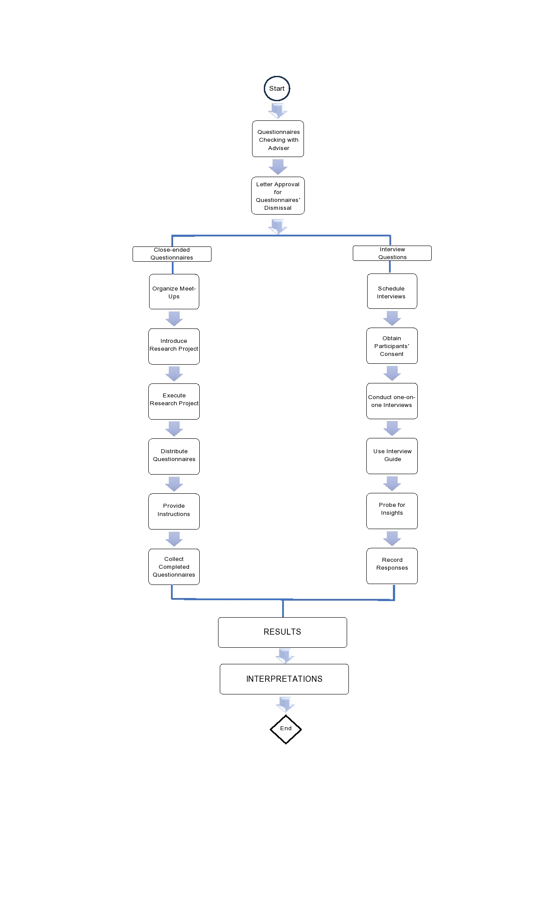

Figure 3.1 Data Collection Process

Figure 3.1 illustrates the data collection process, detailing the sequential steps involved and the flow of data. Initially, researchers review the questionnaires with their advisor and obtain necessary consents. Subsequently, approval is sought from the relevant authorities to gather data from the target respondents. The process then entails arranging meetings with the respondents to collect data, as elaborated in section 3.1.3. Once the data collection is completed, the gathered data is scrutinized to identify results and interpret findings.

## 3.1.1 Research Respondents

In the evaluation of the budget-friendly home automation prototype, researchers employ purposive sampling, a non-probability sampling method, to select participants who possess specific characteristics conducive to providing insightful feedback. By deliberately targeting technology enthusiasts with some background in home automations, researchers aim to gain detailed insights into the prototype's usability and effectiveness. This approach acknowledges that while the prototype is designed to be user-friendly, not all potential users may possess the technical knowledge or enthusiasm necessary to provide meaningful feedback. Therefore, by focusing on individuals who are well-equipped to evaluate the technological aspects of the prototype, researchers ensure that the feedback gathered is relevant, informed, and conducive to the iterative refinement of the product. Through this targeted sampling strategy, the research aims to enhance the quality and relevance of the data collected, ultimately contributing to the development of a more effective and user-friendly final product.

## 3.1. 2 Data Collection Instruments

In evaluating the budget-friendly home automation prototype, researchers utilize close-ended questionnaires and interviews as primary data collection methods. Close-ended questionnaires offer structured feedback gathering, enabling efficient collection of quantitative data from a broader sample of technology enthusiasts. This method facilitates statistical analysis to identify trends and areas for improvement. Interviews provide a deeper exploration of participants' experiences and perspectives through open-ended discussions, uncovering nuanced insights and understanding the reasons behind their responses. By combining both methods, researchers ensure a comprehensive evaluation, guiding iterative refinements to better meet users' needs and expectations.

# 3.1.3 D**ata Collection Procedure for Questionnaires and Interview Questions**

**Close-ended Questionnaires:**

Step 1: Meet-ups are organized for technology enthusiasts in local

communities.

Step 2: At the meet-ups, researchers introduce the research project and invite interested individuals to participate.

Step 3: Printed copies of the close-ended questionnaire are distributed to selected participants at the meet-ups, along with pens or pencils for completion.

Step 4: Participants are provided with clear instructions on how to complete the questionnaire, including the deadline for submission and contact information for any queries.

Step 5: Completed questionnaires are collected at the end of the meet-up.

**Interview Questions:**

Step 1: Researchers scheduled interview appointments with participants at mutually convenient times and location.

Step 2: Began each interview by obtaining participants' consent to record the conversation for accurate note-taking purposes.

Step 3: One-on-one interviews with participants personally are conducted, creating a comfortable and conducive environment for open discussion.

Step 4: Used the interview guide to facilitate structured discussions, probing for detailed insights and perspectives on the prototype.

# 3.1.4 Data Results and Interpretations

This segment will act as a platform to showcase and assess the data gathered, offering valuable insights into the efficacy of the proposed home automation system. Through careful scrutiny of the data and exploration of research outcomes, this segment aims to shed light on the system's effectiveness in addressing various aspects of modern home automation. By delving into the data and its analysis, readers will gain a deeper understanding of the study's objectives and the potential impact of the proposed system on individuals. The subsequent sections will present the research findings, analysis, thereby enhancing the existing knowledge base in this domain.

## 3.1.4.1 Survey Questionnaires’ Results and Interpretations

*Question 1: “On a scale of 1 to 5, how satisfied are you with the overall usability of the budget-friendly home automation prototype?”*

Figure 3.2

Based on the responses gathered from the question regarding the satisfaction with the overall usability of the budget-friendly home automation prototype:

* Three respondents indicated that they were "Very Satisfied" with the prototype's usability.
* Two respondents reported being "Satisfied" with the prototype's usability.
* No respondents expressed "Neutral," "Dissatisfied," or "Very Dissatisfied" sentiments regarding the prototype's usability.

**Interpretation:**

The majority of respondents (60%) expressed high satisfaction levels with the overall usability of the budget-friendly home automation prototype. This indicates that the prototype has been positively experienced by users, with a significant portion expressing a high degree of satisfaction. The absence of any neutral or negative responses suggests that the prototype effectively meets or exceeds user expectations in terms of usability. Overall, these findings reflect positively on the design and functionality of the budget-friendly home automation prototype, highlighting its success in delivering a satisfactory user experience.

*Question 2: “How would you rate the ease of setting up the prototype?”*

Figure 3.3

Based on the responses gathered from the question regarding the ease of setting up the prototype:

* Two respondents indicated that setting up the prototype was "Very Easy."
* Two respondents reported a "Neutral" sentiment regarding the ease of setting up the prototype.
* One respondent found setting up the prototype "Difficult."

**Interpretation:**

The responses suggest a mixed perception of the ease of setting up the prototype. While a significant portion of respondents found the setup process either "Very Easy" or "Neutral," indicating a relatively smooth experience, there is also a notable minority who perceived it as "Difficult." The presence of both positive and negative sentiments highlights potential areas for improvement in the setup process of the prototype. Further investigation into the specific challenges faced by respondents who found the setup difficult could provide valuable insights for refining the setup process and enhancing user experience. Overall, these findings underscore the importance of streamlining the setup process to ensure a more consistent and user-friendly experience for all users.

*Question 3: “Do you find the features useful?”*

Figure 3.4

Based on the responses gathered for Question 3 regarding the usefulness of the features:

* Four respondents strongly agreed that they find the features useful.
* One respondent agreed that they find the features useful.

**Interpretation:**

The overwhelming majority of respondents expressed a positive sentiment towards the usefulness of the features, with all respondents either strongly agreeing or agreeing. This suggests a high level of satisfaction and appreciation for the functionality provided by the features. The absence of any neutral, disagree, or strongly disagree responses indicates a strong consensus among respondents regarding the usefulness of the features, highlighting their effectiveness in meeting user needs and expectations. Overall, these findings reflect positively on the design and implementation of the features, indicating their successful alignment with user preferences and requirements.

*Question 4: “On a scale of 1 to 5, how satisfied are you with the reliability of the prototype’s real-time notifications?”*

Figure 3.5

Based on the responses gathered from the question regarding the satisfaction with the reliability of the prototype's real-time notifications:

* Two respondents indicated that they were "Very Satisfied" with the reliability of the real-time notifications.
* Two respondents reported being "Satisfied" with the reliability of the real-time notifications.
* One respondent expressed a "Neutral" sentiment regarding the reliability of the real-time notifications.

**Interpretation:**

The majority of respondents expressed satisfaction with the reliability of the prototype's real-time notifications, with a combined total of four respondents rating their satisfaction as either "Very Satisfied" or "Satisfied." This suggests that the real-time notifications feature is generally perceived positively by users, indicating that it effectively delivers timely and accurate updates. Additionally, the presence of a respondent who expressed a "Neutral" sentiment suggests that there may be some variability in the reliability of the notifications, warranting further investigation into potential areas for improvement. Overall, these findings highlight the overall effectiveness of the real-time notifications feature in meeting user expectations for reliability.

*Question 5: “How likely are you to recommend the budget-friendly home automation prototype to a friend or colleague?”*

Figure 3.6

Based on the responses gathered from the question regarding the likelihood of recommending the budget-friendly home automation prototype to others:

* One respondent indicated that they were "Very Likely" to recommend the prototype.
* Four respondents reported being "Somewhat Likely" to recommend the prototype.
* No respondents expressed "Neutral," "Somewhat Unlikely," or "Not Likely at All" sentiments regarding recommending the prototype.

**Interpretation:**

The majority of respondents expressed a positive inclination towards recommending the budget-friendly home automation prototype to others, with a combined total of five respondents indicating that they were either "Very Likely" or "Somewhat Likely" to do so. This suggests that the prototype has been positively received by users, with a significant portion expressing a willingness to endorse it to friends or colleagues. The absence of any negative sentiments regarding recommendation indicates a favorable overall perception of the prototype's value and utility. Overall, these findings reflect positively on the prototype's potential for adoption and acceptance among potential users.

*Question 6: “Have you encountered any technical issues or challenges while using the prototype?”*

Figure 3.7

Based on the responses gathered for Question 6 regarding encountered technical issues or challenges while using the prototype:

* One respondent answered "Yes."
* One respondent mentioned encountering "Nothing Serious."
* One respondent mentioned encountering issues "Accidentally."
* Two respondents reported encountering "None at all."

**Interpretation:**

The responses indicate a varied experience among users regarding technical challenges encountered while using the prototype. While the majority of respondents (60%) reported no technical issues at all, a small portion mentioned encountering minor issues or challenges, such as those categorized as "Nothing Serious" and "Accidentally." However, it's noteworthy that one respondent explicitly mentioned encountering technical issues. This highlights the importance of addressing any technical challenges promptly to ensure a seamless user experience. Overall, these findings suggest that while the majority of users did not encounter significant technical issues, there may still be room for improvement in ensuring the prototype's robustness and reliability.

*Question 7: “Would you consider purchasing the budget-friendly home automation prototype for your own use?”*

Figure 3.8

Based on the responses gathered for Question 7 regarding the intention to purchase the budget-friendly home automation prototype:

* All respondents (100%) indicated that they would consider purchasing the prototype for their own use.

Interpretation:

The unanimous agreement among respondents to consider purchasing the budget-friendly home automation prototype reflects a high level of interest and positive perception of the product. The fact that all respondents expressed willingness to purchase suggests that the prototype effectively meets their needs and preferences, and they perceive it as a valuable addition to their homes. This overwhelming agreement underscores the potential market demand for the product and indicates promising prospects for its adoption and commercial success. Overall, these findings reflect positively on the prototype's appeal and potential for widespread acceptance among potential users.

*Question 8: “How satisfied are you with the overall value of money offered by the prototype?”*

Figure 3.9

Based on the responses gathered from the question regarding the satisfaction with the overall value of money offered by the prototype:

* All respondents (100%) indicated that they were "Satisfied" with the overall value of money offered by the prototype.

**Interpretation:**

The responses uniformly indicate a high level of satisfaction with the overall value of money offered by the prototype. All respondents expressed satisfaction with the perceived balance between the cost of the prototype and the benefits or features it provides. This suggests that users find the prototype to be cost-effective and worthwhile, considering it provides satisfactory value for the money spent. The absence of any neutral or negative responses further underscores the positive perception of the prototype's affordability and value proposition. Overall, these findings reflect positively on the pricing strategy and perceived affordability of the prototype, indicating successful alignment with user expectations and preferences

*Question 9: “How often do you use the remote-control capabilities of the prototype to access home automation features?”*

Figure 3.10

Based on the responses gathered from the question regarding the frequency of using the remote-control capabilities of the prototype to access home automation features:

* All respondents (100%) indicated that they use the remote-control capabilities "Multiple Times a day."

**Interpretation:**

The responses uniformly indicate that all respondents use the remote-control capabilities of the prototype to access home automation features multiple times a day. This suggests that the remote-control functionality is highly utilized by users and plays a significant role in their daily interaction with the prototype. The absence of any respondents indicating lower usage frequencies (e.g., once a day, several times a week, once a week, rarely, or never) suggests that the remote-control capabilities are an integral and essential aspect of the prototype's functionality. Overall, these findings highlight the importance and effectiveness of the remote-control capabilities in facilitating convenient and frequent access to home automation features, contributing to a positive user experience.

*Question 10: “How satisfied are you with the responsiveness of the prototype’s remote-control capabilities?”*

Figure 3.11

Based on the responses gathered from the question regarding the satisfaction with the responsiveness of the prototype's remote-control capabilities:

* Two respondents indicated that they were "Very Satisfied" with the responsiveness of the remote-control capabilities.
* Two respondents reported being "Satisfied" with the responsiveness of the remote-control capabilities.
* One respondent expressed a "Neutral" sentiment regarding the responsiveness of the remote-control capabilities.

**Interpretation:**

The majority of respondents (80%) expressed positive sentiments towards the responsiveness of the prototype's remote-control capabilities, with a combined total of four respondents indicating either "Very Satisfied" or "Satisfied." This indicates that the remote-control capabilities are generally perceived favorably by users, with most respondents experiencing satisfactory responsiveness in their interactions with the prototype. Additionally, the presence of a respondent who expressed a "Neutral" sentiment suggests that there may be some variability in the responsiveness experienced by users, warranting further investigation into potential areas for improvement. Overall, these findings reflect positively on the effectiveness of the remote-control capabilities in facilitating user interactions with the prototype, with the majority of respondents expressing satisfaction with its responsiveness.

## 3.1.4.2 Interview Questions’ Results and Interpretations

*Question 1: “**What features of ToucHome did you find most practical, and what made them stand out to you?”*

|  |  |
| --- | --- |
| **Respondent** | **Most Practical Feature** |
| 1 | Notification Alert System where homeowners be updated about situations that may require immediate action. |
| 2 | Notification Alert System will help on updating me about the safety of the house. |
| 3 | Cost-effective, it is very budget friendly especially to those average people who wants to experience convenience. |
| 4 | Fire and Smoke sensors is a very big help for feeling at ease, especially with our heat problem nowadays. |
| 5 | Remote control, I can easily toggle off and on the lights when I forgot to do this in my house. |

Table 3.1

Based on the responses gathered from the question regarding the most practical features of ToucHome and what made them stand out to the respondents:

1. Respondent 1 found the "Notification Alert System" to be the most practical feature, as it allows homeowners to stay updated about situations that may require immediate action.

2. Respondent 2 also highlighted the "Notification Alert System" as the most practical feature, emphasizing its role in updating them about the safety of the house.

3. Respondent 3 identified the "Cost-effectiveness" of ToucHome as the most practical feature, noting its affordability and suitability for average people seeking convenience.

4. Respondent 4 found the "Fire and Smoke sensors" to be the most practical feature, appreciating their contribution to feeling at ease, particularly given concerns about heat problems nowadays.

5. Respondent 5 emphasized the "Remote control" feature as the most practical, citing its convenience in easily toggling off and on the lights when forgotten.

**Interpretation:**

The responses highlight a variety of features of ToucHome that respondents found practical and noteworthy. The "Notification Alert System" emerged as a standout feature, appreciated for its ability to keep homeowners informed about safety-related situations. Additionally, the "Cost-effectiveness" of ToucHome was recognized as appealing to average individuals seeking convenience without breaking the budget. The inclusion of "Fire and Smoke sensors" was valued for enhancing peace of mind amid concerns about safety, while the "Remote control" feature was praised for its convenience in managing home lighting. Overall, these insights underscore the importance of practicality, affordability, and convenience in the design and functionality of ToucHome, aligning with user needs and preferences.

*Question 2: “**How would you rate the ease of configuring the prototype? Were there any challenges or difficulties you encountered during the setup process?”*

|  |  |
| --- | --- |
| **Respondent** | **Challenges encountered configuring ToucHome** |
| 1 | No |
| 2 | Buttons are not very specified. |
| 3 | No |
| 4 | No |
| 5 | Delay responses because of low interconnectivity. |

Table 3.2

Based on the responses gathered from the question regarding the ease of configuring the ToucHome prototype and any challenges encountered during the setup process:

* Respondent 1 reported no challenges or difficulties encountered during the configuration of ToucHome.
* Respondent 2 noted that the buttons were not very specified, indicating a lack of clarity in the interface design which may have made the setup process less intuitive.
* Respondent 3 did not encounter any challenges or difficulties during the configuration of ToucHome.
* Respondent 4 also reported no challenges or difficulties encountered during the setup process.
* Respondent 5 experienced delays in responses due to low interconnectivity during the setup, suggesting potential issues with network connectivity that affected the configuration experience.

**Interpretation:**

The majority of respondents (60%) did not encounter significant challenges or difficulties during the configuration of the ToucHome prototype, indicating a relatively smooth setup process for most users. However, one respondent highlighted an issue with the lack of specificity in the buttons, which may have impacted the ease of use and user experience. Additionally, another respondent experienced delays in responses due to low interconnectivity, suggesting potential issues with network reliability that affected the setup process. These findings highlight the importance of intuitive interface design and robust network connectivity in ensuring a seamless setup experience for users. Addressing these challenges can improve the overall usability and user satisfaction with the ToucHome prototype.

*Question 3: “How would you rate the overall value for money offered by the budget-friendly home automation prototype? Do you feel that it provides sufficient functionality and features relative to its cost?”*

|  |  |
| --- | --- |
| **Respondent** | **Rate for the ToucHome’s cost-effectiveness** |
| 1 | Very affordable |
| 2 | Affordable and reliable even it’s a low-cost system |
| 3 | Affordable |
| 4 | Affordable |
| 5 | Worthy for its price |

Table 3.3

Based on the responses gathered from the question regarding the overall value for money offered by the budget-friendly home automation prototype and whether it provides sufficient functionality and features relative to its cost:

* Respondent 1 rated ToucHome as "Very affordable."
* Respondent 2 described ToucHome as "Affordable and reliable even it’s a low-cost system."
* Respondent 3 rated ToucHome as "Affordable."
* Respondent 4 also found ToucHome to be "Affordable."
* Respondent 5 expressed that ToucHome is "Worthy for its price."

**Interpretation:**

All respondents provided positive assessments of the budget-friendly home automation prototype's value for money, with descriptions ranging from "Very affordable" to "Worthy for its price." These responses indicate that the prototype is perceived as offering sufficient functionality and features relative to its cost, with respondents finding it affordable, reliable, and worthy of its price point. Such feedback suggests that the prototype effectively meets user expectations for cost-effectiveness and provides good value for the investment made. Overall, these findings highlight the positive reception of ToucHome in terms of affordability and perceived value, indicating a strong alignment between its cost and the benefits it delivers to users.

*Question 4: “**As a technology enthusiast, why integrating smoke and fire sensors useful, especially now when fire accidents are common?”*

|  |  |
| --- | --- |
| **Respondents** | **Importance of integrating fire and smoke sensors to ToucHome** |
| 1 | Utmost concern to consider especially fire accidents nowadays. |
| 2 | Very important to prevent fire accidents. |
| 3 | It is essential for ensuring safe environment. |
| 4 | It is very important to avoid fire accidents. |
| 5 | Very important to avoid houses be burned. |

Table 3.4

Based on the responses gathered from the question regarding the importance of integrating fire and smoke sensors into ToucHome, especially considering the prevalence of fire accidents:

* Respondent 1 expressed that it is of "Utmost concern to consider especially fire accidents nowadays."
* Respondent 2 stated that it is "Very important to prevent fire accidents."
* Respondent 3 emphasized that it is "Essential for ensuring a safe environment."
* Respondent 4 highlighted that it is "Very important to avoid fire accidents."
* Respondent 5 reiterated that it is "Very important to avoid houses being burned."

**Interpretation:**

The responses uniformly underscore the critical importance of integrating fire and smoke sensors into ToucHome, particularly in light of the prevalence of fire accidents in contemporary times. Respondents expressed concerns about the potential risks associated with fire accidents and emphasized the necessity of preventive measures to ensure safety. These sentiments highlight the significant role that fire and smoke sensors play in enhancing home safety and preventing potential disasters. By detecting smoke and fire hazards early and providing timely alerts, ToucHome can effectively contribute to minimizing the risk of fire accidents and protecting both property and lives. Overall, these insights highlight the paramount importance of integrating such safety features into home automation systems like ToucHome, reflecting a proactive approach to safeguarding against fire-related risks.

*Question 5: “**Looking ahead, ae there any additional features or improvements you would like to see implemented in future versions of the prototype?”*

|  |  |
| --- | --- |
| **Respondents** | **Additional features/improvements to be implemented in future versions of ToucHome** |
| 1 | Must have energy backup. |
| 2 | Installer must have tracking equipment in addressing shortcomings. |
| 3 | Secure seamless online connectivity. |
| 4 | Power supply needed. |
| 5 | Ensure to address delay responses caused by slow internet connection. |

Table 3.5

Based on the responses gathered from the question regarding additional features or improvements respondents would like to see implemented in future versions of ToucHome:

* Respondent 1 emphasized the necessity of having an "energy backup," suggesting a feature that ensures uninterrupted operation even during power outages.
* Respondent 2 suggested the implementation of "tracking equipment" for installers to address shortcomings effectively, indicating a desire for improved installation and maintenance processes.
* Respondent 3 prioritized "secure seamless online connectivity," highlighting the importance of robust and reliable internet connectivity for remote monitoring and control.
* Respondent 4 expressed the need for "power supply," indicating a requirement for reliable and stable power sources to support the operation of ToucHome.
* Respondent 5 urged for measures to address "delay responses caused by slow internet connection," underscoring the importance of optimizing system performance to mitigate the impact of connectivity issues.

**Interpretation:**

The responses highlight various areas for potential enhancements and additional features in future versions of ToucHome. These include improvements related to power backup, installer tracking, online connectivity, power supply, and addressing delays caused by slow internet connections. These suggestions reflect user priorities and preferences, aiming to enhance the reliability, functionality, and user experience of ToucHome. By addressing these areas of concern and incorporating suggested features, future versions of ToucHome can potentially offer greater convenience, reliability, and effectiveness in home automation and security. Overall, these insights provide valuable guidance for the continued development and refinement of ToucHome to better meet user needs and expectations in the future.

## 3.1.4.3 Summary of Results

The data collected from survey questionnaires and interviews provide valuable insights into the usability, satisfaction, challenges, and future improvements of ToucHome, a budget-friendly home automation prototype. Here's a concise summary:

1. **Usability and Satisfaction:** Overall, users expressed high satisfaction with ToucHome's usability, citing its affordability and user-friendly design. Key features like budget-friendliness, fire and smoke integration, real-time notifications, and remote control capabilities were deemed particularly useful.
2. **Challenges and Areas for Improvement:** Some users encountered challenges during setup, such as unspecified buttons and connectivity issues. Suggestions for improvement included enhancing usability for non-tech-savvy users and addressing potential overload issues with the website.
3. **Future Enhancements:** Users provided valuable suggestions for future improvements, including implementing energy backup, installer tracking equipment, secure online connectivity, and addressing delays caused by slow internet connections.
4. **Positive Intentions and Perceptions**: The majority of respondents expressed positive intentions towards purchasing ToucHome and rated its overall value for money as satisfactory. Integration of fire and smoke sensors was emphasized for enhanced safety.
5. **User Recommendations and Preferences:** Users indicated a likelihood of recommending ToucHome to others and expressed interest in additional features such as energy backup and improved online connectivity.

In summary, while ToucHome received positive feedback for its affordability and practical features, there are areas for improvement in setup processes, technical challenges, and the incorporation of additional features. Leveraging user feedback can guide future iterations of ToucHome to deliver enhanced functionality and user experience in smart home automation and security.

**Close-Ended Questionnaires’ Results Summary**

The survey offers valuable insights into how stakeholders perceive and feel about the proposed home automation system. To visually represent the overall consensus among participants regarding different aspects of the system, a radar graph (Fig. 3.12) was utilized. Here, each axis of the graph corresponds to a question from the questionnaires, while the radius of the graph reflects the level of agreement, with a score of 1 indicating the highest level of agreement (e.g., 'very satisfied', 'very easy'). The legends (Q1-Q10) represent the questions, and their details are provided in a table below (Table 3.6).

Importantly, the size of the area enclosed by the radar graph reflects the collective level of positive responses toward implementing ToucHome. A larger area indicates higher overall agreement and stronger support for system implementation.

Analysis of the closed-ended questionnaire results revealed varying levels of agreement among participants across different dimensions of the system. Particularly, participants showed high satisfaction with the system's cost-effectiveness, integration of fire and smoke sensors, and remote control features. Additionally, stakeholders expressed positive sentiments regarding the system's importance in addressing contemporary needs.

Figure 3.12

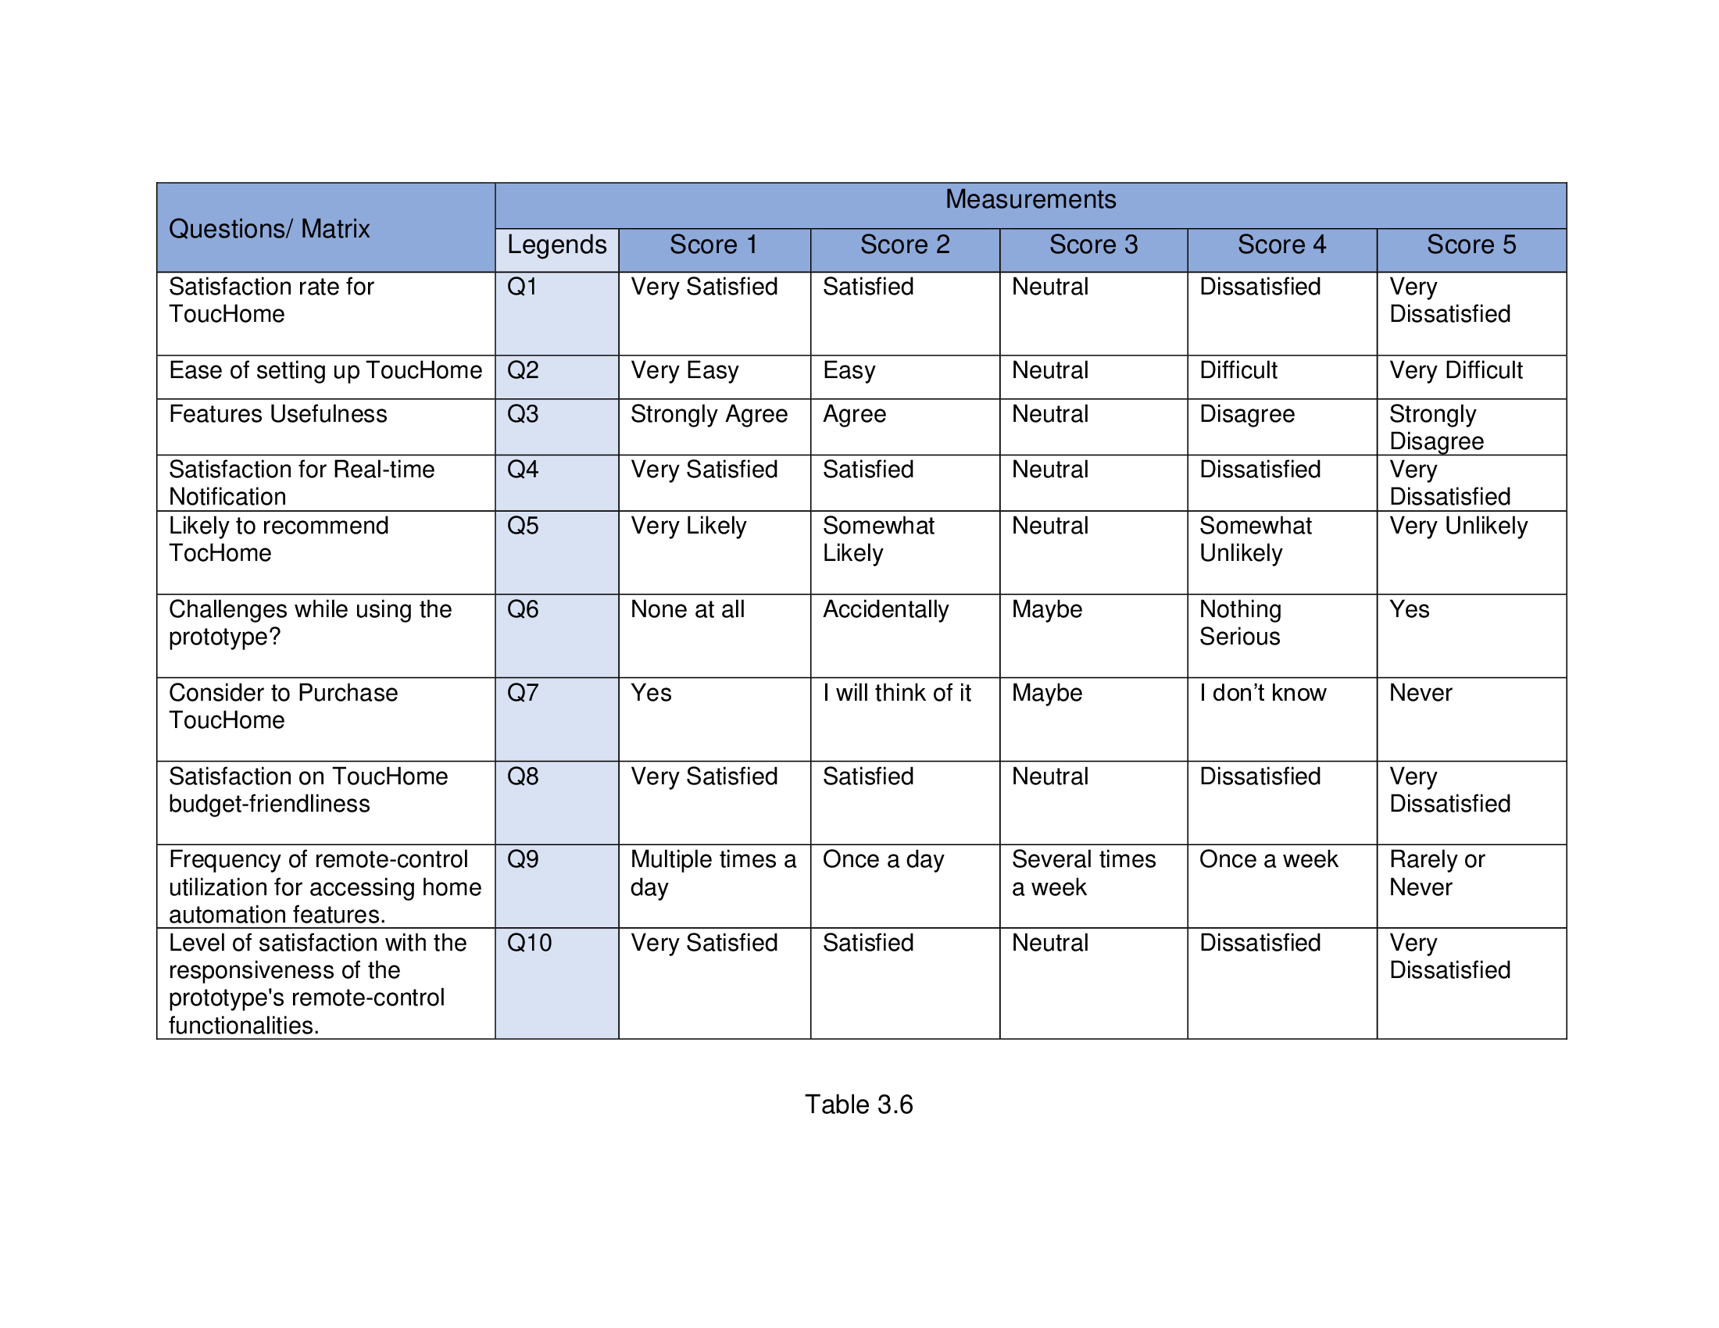

# 3.1.5 Data Validation and Reliability Measures

Data validation and reliability measures are crucial because they ensure the accuracy, credibility, and trustworthiness of research findings. By implementing these measures, researchers can minimize biases, errors, and inconsistencies, thus enhancing the robustness of their conclusions.

## 3.1.5.1 Data Triangulation

Data triangulation is vital because it strengthens the validity and reliability of research findings. By comparing and integrating data from multiple sources such as surveys, interviews, and other relevant sources, researchers can ensure that their conclusions are well-supported and not solely reliant on one type of data. It leads to a more comprehensive understanding of the research topic and enhances the credibility of the findings, facilitating informed decision-making and practical applications.

## **3.1.5.2** **Member Checking**

Member checking will be employed to bolster the credibility of the data further. Participants in the research, including program heads, will have the opportunity to review and confirm the accuracy of the information attributed to them. This validation process enables participants to verify the accuracy of their responses, reducing potential misinterpretations and ensuring the precision of the captured data.

## **3.1.5.3** **Data Verification**

For manually entered data, researchers will implement cross-verification procedures. The outputs of data entry will be compared with original data sources, such as recorded interviews and collected survey questionnaires, to authenticate the accuracy of transcribed information.

## 3.1.5.4 Consistency Checks

To ensure the reliability of collected data, consistency checks will be conducted to detect any inconsistencies or discrepancies in responses. Any irregularities will be promptly addressed, with additional follow-up measures taken as necessary.

Through adherence to these validation and reliability measures, researchers aim to generate precise and dependable data, thereby enhancing the integrity of research findings. These safeguards will play a crucial role in facilitating the analysis and interpretation of data, contributing to a comprehensive and well-founded evaluation of the Cost-Effective Home Automation Infused with Sensors Integration, Remote Control, and Live Notifications.

# 3.1.6 Ethical Consideration of the Research

Ethical considerations are paramount in any research endeavor, ensuring the protection of participants' rights, confidentiality, and integrity. The following are several ethical considerations that must be addressed to uphold the highest standards of ethical conduct.

1. Authorization and Approval: Authorization and approval from the research adviser to collect data using the questionnaires and interview questions will be obtained prior to the commencement of data collection. This ensures that the research methodology aligns with academic standards and ethical guidelines. The research adviser will review the proposed data collection instruments to ensure they are appropriate, relevant, and ethically sound. Additionally, the adviser's approval provides an added layer of oversight to ensure that the rights and welfare of participants are protected throughout the research process.
2. Informed Consent: Prior to participating in the research, all participants will be provided with clear and comprehensive information about the purpose, procedures, risks, and benefits of the study. Informed consent will be obtained from each participant, affirming their voluntary participation and understanding of their rights.
3. Confidentiality: Measures will be implemented to safeguard the confidentiality of participants' data. Personal information will be anonymized and stored securely to prevent unauthorized access. Only authorized researchers will have access to the data, and it will be used solely for the purpose of the study.
4. Minimization of Harm: Steps will be taken to minimize any potential harm or discomfort to participants. This includes ensuring that participation is voluntary, minimizing risks associated with data collection, and providing support services if participants experience any distress.
5. Transparency and Integrity: Researchers will conduct the study with honesty, transparency, and integrity. They will accurately report findings, acknowledge any limitations or biases in the research process, and avoid misrepresentation or manipulation of data.

# 3.2 Research Design

This descriptive research aims to develop ToucHome, an inexpensive home automation system. Key objectives include integrating fire and smoke sensors for safety, implementing live notifications for instant security alerts, and enabling remote control functions for simplified device monitoring. The focus is on ensuring safety, affordability, and user-friendly operation. Utilizing the Agile Methodology, our research progresses through the iterative steps characteristic of this approach.

## 3.2.1 Agile Methodology

In the context of our research on developing ToucHome, the Agile methodology offers invaluable benefits for ensuring the reliability, dependability, and trustworthiness of the final product. By employing Agile principles, we can conduct multiple testing iterations throughout the development process. This iterative approach allows us to continuously refine and improve ToucHome, addressing any issues or challenges identified during testing. Additionally, close collaboration with stakeholders and end-users enables us to gather feedback and insights, ensuring that ToucHome meets their needs and expectations. The adaptability of Agile allows us to quickly respond to changing requirements or priorities, ensuring that ToucHome remains relevant and effective. Transparent tracking of progress ensures visibility and accountability, fostering trust in the reliability of the final product. Overall, Agile provides a structured and effective framework for developing ToucHome, ensuring that it is reliable, dependable, and worthy of trust.

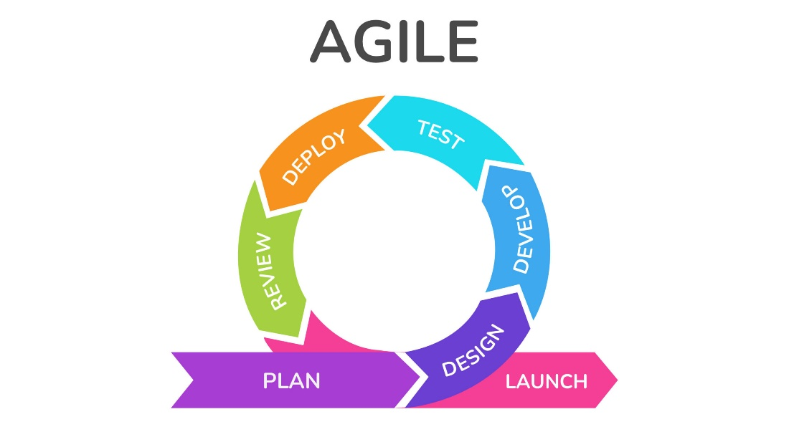

Figure 3.13: AGILE METHODOLOGY

### **3.2.1.1 Planning Stage**

During the planning stage, we will define the project's objectives and scope, focusing on developing ToucHome as a cost-effective home automation system with safety features. We will create a detailed product backlog containing all necessary features, such as integrating fire and smoke detectors, implementing live notifications, and enabling remote control functionalities. Sprint planning meetings will be conducted to prioritize tasks from the backlog for each sprint, ensuring alignment with project goals. Tasks will be further broken down into manageable steps with clear acceptance criteria to facilitate efficient progress and development.

### **3.2.1.2 Designing Phase**

During the designing phase, we will refine project requirements and objectives into detailed design specifications for ToucHome. This involves research, conceptualization, and creation of user interface and experience designs. Additionally, we will study the landscape of the house to determine optimal placement for ToucHome components and assess the flow of wires to ensure efficient installation. Technical specifications and architecture will also be considered. The aim is to ensure usability, functionality, and alignment with project goals in preparation for development.

### **3.2.1.3 Developing Stage**

During the development stage, we will transform the design specifications into a functional prototype of ToucHome. This involves coding and implementation of features such as fire and smoke detectors, live notifications, and remote control capabilities. Prototypes will be built and tested iteratively to identify and address any technical issues early on. The aim is to create a reliable and user-friendly system that meets the requirements outlined in the design phase.

### **3.2.1.4 Testing**

During the testing phase, ToucHome will undergo rigorous evaluation to ensure its functionality, reliability, and performance align with specified requirements and quality standards. This includes unit testing to verify individual components, integration testing to ensure seamless system operation, and system testing to validate overall functionality. Acceptance testing will assess ToucHome against predetermined criteria, while performance testing will evaluate its responsiveness and scalability. User acceptance testing will gather feedback from stakeholders and end-users to refine the system before deployment. Throughout this phase, comprehensive documentation will be maintained to track test cases and results, ensuring ToucHome meets the standards of quality and reliability.

### **3.2.1.5 Review Stage**

The review stage before deployment of ToucHome involves thorough checks and assessments to guarantee compliance with project requirements and quality standards. This includes scrutinizing initial project requirements, conducting comprehensive quality assurance tests, and engaging in user acceptance testing with stakeholders. Documentation related to ToucHome will also be meticulously reviewed for accuracy and completeness, while a rigorous risk assessment will identify and mitigate any potential deployment risks. Upon successful completion of these reviews and obtaining final approval, ToucHome will be considered ready for deployment, ensuring that it meets stakeholder expectations and is poised for release into real-world environments.

### **3.2.1.6 Deployment Stage**

During the deployment stage, ToucHome will undergo final preparations for release and implementation in real-world settings. This involves completing any remaining development tasks and configuring the system to meet the specific requirements of each deployment environment. ToucHome components will be installed in designated locations, with users receiving training on system operation and maintenance. A phased rollout approach will be employed, starting with a pilot or beta testing phase before broader adoption. Ongoing support and maintenance will be provided post-deployment to address any issues and ensure optimal performance. Throughout this stage, close coordination with stakeholders and continuous monitoring will ensure a smooth and successful deployment of ToucHome.

## 3.2.2 ToucHome Features

The budget-friendly smart home solution brings convenience, safety, and peace of mind to your fingertips. Designed with affordability and efficiency in mind, ToucHome utilizes state-of-the-art technology to offer advanced features at a fraction of the cost of traditional home automation systems.

### **3.2.2.1 Affordable and Budget-Friendly**

ToucHome is designed to be cost-effective, making advanced smart home technology accessible to a wider range of users. By utilizing an ESP32 microcontroller and a touchscreen interface that costs just over 1000 pesos, ToucHome significantly reduces the hardware costs associated with traditional home automation systems. This classification emphasizes ToucHome's affordability and its ability to provide advanced features at a fraction of the cost.

### **3.2.2.2 Safety and Security**

With integrated fire and smoke sensors, ToucHome prioritizes the safety and security of its users and their homes. These sensors are strategically placed throughout the home to detect potential fire hazards in real-time. In the event of a fire, ToucHome immediately alerts users through email alerts, allowing them to take prompt action to protect themselves and their property. This classification underscores ToucHome's commitment to ensuring the safety and well-being of its users.

### **3.2.2.3 Environmental Monitoring**

ToucHome features humidity detection capabilities, enabling real-time monitoring of humidity levels in each room. This allows users to maintain a comfortable and healthy living environment by ensuring optimal humidity levels are maintained. By providing environmental data, ToucHome empowers users to make informed decisions about their home environment and take proactive measures to address any issues that arise. This classification highlights ToucHome's focus on enhancing the overall comfort and well-being of its users.

### **3.2.2.4 Remote Control and Accessibility**

ToucHome offers remote control functionality, allowing users to manage their home's settings from anywhere in the world. Whether they're at work, on vacation, or simply on the go, users can use their smartphone or tablet to control lights. ToucHome's user-friendly website also allows users to add additional recipients to receive email notifications, ensuring that important alerts are never missed, even if the primary user is unavailable. This classification emphasizes ToucHome's convenience and accessibility, enabling users to stay connected and in control of their home environment at all times.

### **3.2.2.5 Notification Alert System**

ToucHome provides a robust notification and alert system to keep users informed and safe. In the event of a possible fire accident, ToucHome sends email alerts to users, providing detailed information about the temperature and humidity levels detected. This allows users to quickly assess the situation and take appropriate action to mitigate any risks. By proactively communicating with users, ToucHome ensures that they are well-informed and able to respond effectively to any emergencies that may arise. This classification underscores ToucHome's commitment to safety and communication with its users.

# 3.2.3 ToucHome System Flow

The code starts by getting everything ready, like setting up the WiFi connection and defining what different parts of the hardware do. Then, it keeps looping through the same set of actions.

First, it checks if it's connected to the internet. If not, it tries to connect. Then, it updates the current time and checks the weather. Next, it listens for any commands from a display. If it gets any, it reacts accordingly, like turning things on or off. After that, it reads the sensors to check things like temperature, humidity, smoke, and fire levels. If the smoke or fire levels are too high, it sends an email alert. Finally, it sends all the sensor readings to the display so you can see what's going on in real-time. Basically, it's a smart system that keeps an eye on things and lets you know if there's any danger.

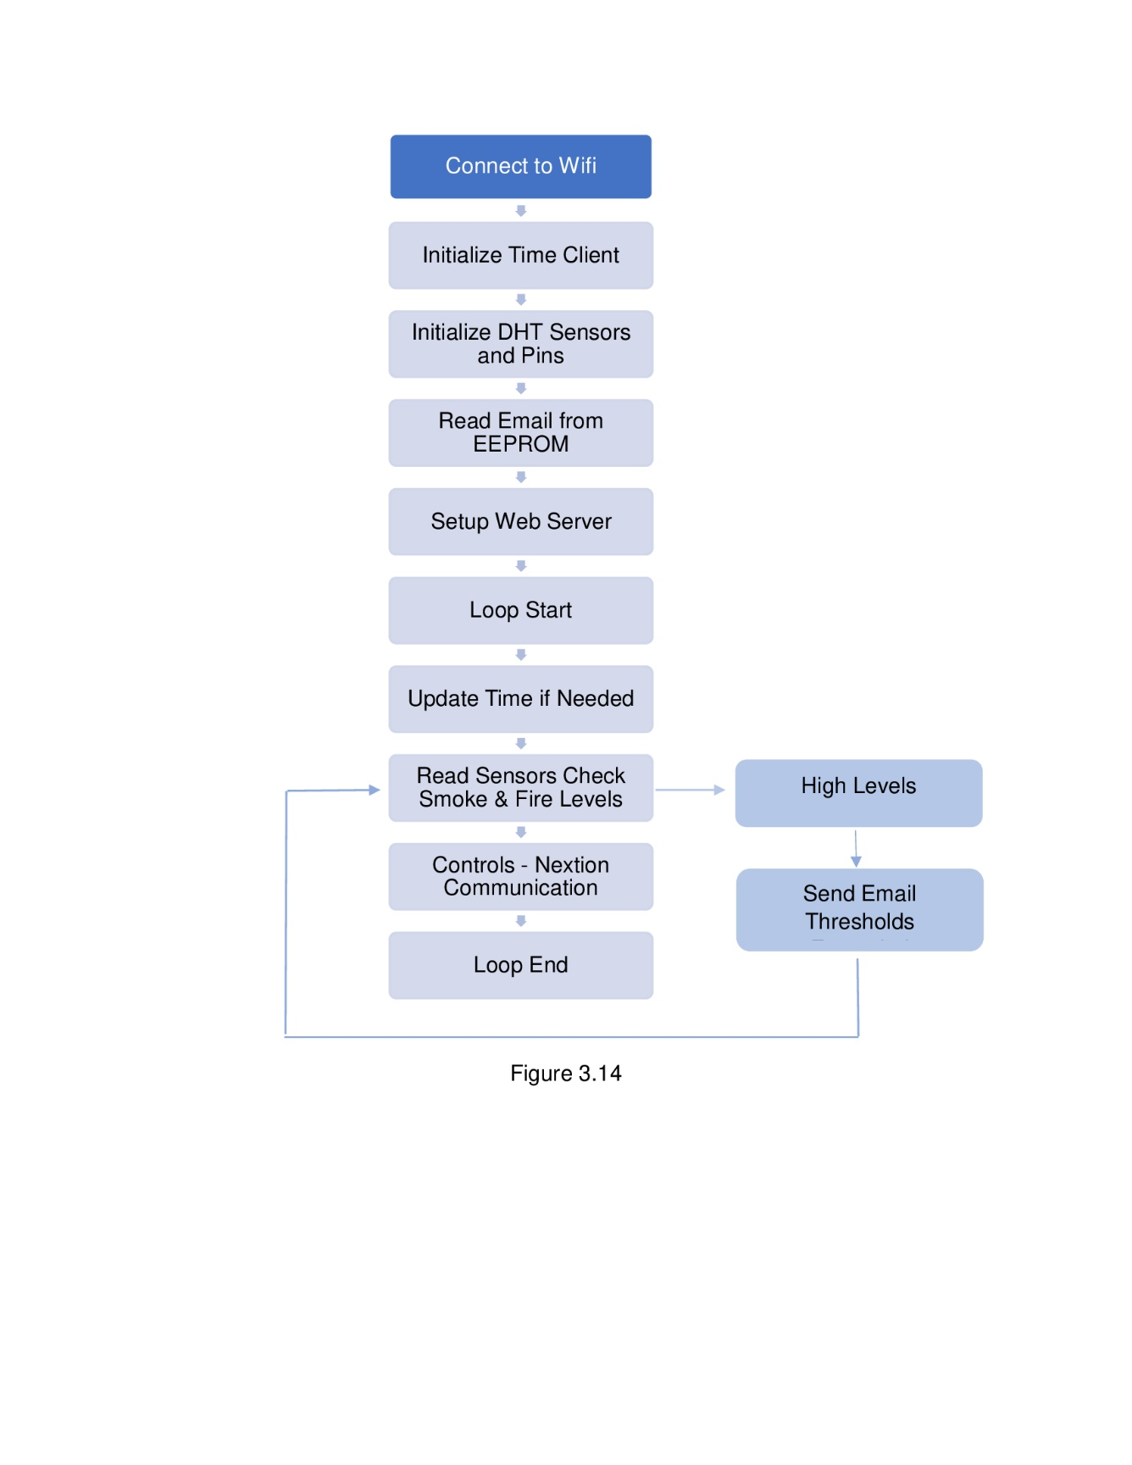

# 3.2.4 ToucHome Installation Process

To install the touchhome in your home, start by consulting the blueprint or wiring structure of your house to understand the electrical layout. Next, gather all the necessary components: a microcontroller (such as an esp32), sensors (like temperature, humidity, and fire and smoke sensors), relays (if controlling electrical devices), and a display unit (nextion HMI).

Contact a qualified electrician to inspect the wiring and provide guidance on integrating the additional components safely. Share the blueprint or wiring structure with them to assist in planning the installation process. Once you have their approval and advice, proceed with the following steps:

1. Mounting Sensors: Identify suitable locations for mounting the sensors based on their function. For example, place temperature and humidity sensors in areas where you want to monitor climate conditions, and motion sensors in areas where motion detection is desired. Use appropriate mounting hardware to secure the sensors in place.

2. Wiring Sensors: Connect each sensor to the microcontroller according to the wiring diagram provided with the code or based on the electrician's recommendations. Typically, this involves connecting the sensor's power, ground, and data pins to the corresponding pins on the microcontroller.

3. Connecting Relays: using relays to control electrical devices, such as lights or appliances, ensure they are safely connected to the microcontroller and powered appropriately. Follow the relay manufacturer's instructions for wiring and connections.

4. Installing Display Unit: Position the display unit in a convenient location where it is easily visible. Connect it to the microcontroller using the required cables or wires, ensuring a secure connection.

5. Testing: Power on the system and upload the pre-installed code to the microcontroller using the Arduino IDE. Verify that all sensors are functioning correctly and providing accurate readings. Evaluate any connected relays to ensure they respond appropriately to commands from the microcontroller.

6. Final Inspection: Conduct a thorough inspection of all installed components and wiring connections. Address any issues or discrepancies found during testing and make necessary adjustments to ensure everything is in working order.

7. Safety Checks: Before finalizing the installation, ensure all wiring is properly insulated and secured to prevent electrical hazards. Double-check that the installation complies with safety standards and regulations.

8. Maintenance and Support: Keep the electrician's contact information handy for future maintenance or modifications. Regularly inspect the system for any signs of wear or malfunction.

# 3.3 Future Improvements of Home Automation

As technology continues to advance rapidly, the realm of home automation stands poised for exciting developments and innovations. In this section, we explore potential future improvements in home automation, envisioning a future where smart homes are even more intuitive, efficient, and seamlessly integrated into our daily lives. The following are the expected improvements to be taken action.

**1. Advanced Security Features:** Introduce robust encryption protocols and multi-factor authentication to bolster the security of ToucHome's online connectivity, ensuring protection against cyber threats and unauthorized access.

**2. Seamless Integration with Smart Devices:** Expand compatibility with a wider range of smart home devices and platforms, allowing users to seamlessly integrate ToucHome with their existing smart appliances, voice assistants, and home automation ecosystems.

**3. Remote Diagnostics and Maintenance:** Introduce remote diagnostics capabilities to facilitate proactive monitoring of ToucHome's performance and troubleshoot potential issues remotely, minimizing downtime and enhancing overall reliability.

**4. Voice Control and Natural Language Processing:** Integrate voice control functionality and natural language processing capabilities, enabling users to interact with ToucHome using voice commands for hands-free operation and enhanced convenience.

# 3.4 Summary

ToucHome, a budget-friendly home automation prototype, received positive feedback across various dimensions, as gleaned from survey questionnaires and interview responses. Users expressed high satisfaction with its usability, affordability, and reliability, highlighting features like real-time notifications, remote control capabilities, and fire and smoke integration as particularly useful. The majority of respondents indicated a strong likelihood of recommending ToucHome to others, showcasing its potential for widespread adoption.

Despite generally positive sentiments, some users encountered challenges during setup, such as issues with interface clarity and network connectivity. Suggestions for future improvements included implementing energy backup, improving online connectivity, and addressing delays caused by slow internet connections. These insights provide valuable guidance for enhancing ToucHome's functionality and user experience in future iterations.

Furthermore, ToucHome presents a promising solution for affordable and accessible home automation, offering valuable features that enhance convenience, safety, and peace of mind for users. With continued refinement and the incorporation of user feedback, ToucHome has the potential to become a leading choice in the home automation market.

# 3.5 Conclusion

ToucHome stands as a testament to the convergence of affordability, innovation, and safety in the realm of home automation. By integrating budget-friendly features with essential functionalities like fire and smoke sensors, real-time notifications, and remote control capabilities, ToucHome offers users a comprehensive solution to enhance their living spaces.

Through extensive user feedback collected via surveys and interviews, ToucHome has demonstrated its ability to resonate with users, garnering high satisfaction ratings across various aspects such as usability, reliability, and overall value for money. Users particularly appreciate the convenience and peace of mind offered by features like the notification system and remote control, while the inclusion of safety features like fire and smoke sensors adds an invaluable layer of protection to homes.

While the prototype has received commendation for its strengths, it is not without its challenges. Some users encountered difficulties during setup, indicating areas for improvement in user interface design and network connectivity. Moreover, suggestions for future enhancements, such as energy backup and improved online connectivity, underscore the potential for ToucHome to evolve and adapt to the evolving needs of users.

In conclusion, ToucHome represents more than just a smart home solution—it embodies a vision of accessible, yet sophisticated, home automation technology that empowers users to create safer, more efficient living environments. With continued refinement and innovation, ToucHome has the potential to revolutionize the way people interact with their homes, making smart living more attainable and impactful for individuals and families worldwide.

# 3.6 Recommendations

Based on the extensive feedback and analysis gathered, it is evident that ToucHome has made significant strides in providing an accessible and effective home automation solution. However, to further enhance its appeal and address the identified areas for improvement, the following recommendations are proposed:

1. **Enhanced User Experience:** Invest in refining the user interface to ensure intuitive navigation and seamless setup processes. Clearer labeling and instructions can minimize user confusion, particularly for less tech-savvy individuals.

2. **Network Reliability**: Address any issues related to network connectivity to mitigate delays in responses or potential overload issues with online platforms. Ensuring stable and robust internet connectivity is crucial for the smooth functioning of ToucHome.

3. **Feature Expansion:** Consider incorporating additional features suggested by users, such as energy backup systems and installer tracking equipment. These enhancements can further differentiate ToucHome in the market and cater to a wider range of user needs and preferences.

4**. Continuous Improvement:** Establish a feedback loop with users to gather insights on ongoing usage experiences and identify areas for continuous improvement. Regular updates and firmware upgrades can address emerging challenges and introduce new functionalities to enhance user satisfaction.

5. **Marketing and Education:** Increase awareness of ToucHome through targeted marketing campaigns that highlight its unique features and benefits. Additionally, provide educational resources and tutorials to empower users in maximizing the potential of ToucHome and troubleshooting common issues.

By implementing these recommendations, ToucHome can solidify its position as a leading budget-friendly home automation solution, delivering unparalleled value, convenience, and safety to users worldwide.

# REFERENCES

**Books/Journal Articles**

Al-Fuqaha, A., Guizani, M., Mohammadi, M., Aledhari, M., & Ayyash, M.

(2015). Internet of Things: A survey on enabling technologies,

protocols, and applications. IEEE Communications Surveys & Tutorials, 17(4), 2347-2376.

Atzori, L., Iera, A., & Morabito, G. (2010). The Internet of Things: A survey.

Computer Networks, 54(15), 2787-2805.

Ayala, J. L. (2013). The microcontroller idea book: Circuits, programs, &

applications featuring the 8052-BASIC microcontroller. Cengage

Learning.

Brush, A. J. B., Lee, J., & Mahajan, R. (2011). Home automation in the wild:

Challenges and opportunities. In Proceedings of the SIGCHI

Conference on Human Factors in Computing Systems (pp. 2115-2124).

Cheng, T. H. K., Chan, S. C. F., & Lee, E. W. M. (2007). A review of smart

homes present state and future challenges. Computer-Aided Civil and

Infrastructure Engineering, 22(5), 261-279.

Gubbi, J., Buyya, R., Marusic, S., & Palaniswami, M. (2013). Internet of

Things (IoT): A vision, architectural elements, and future directions.

Future Generation Computer Systems, 29(7), 1645-1660.

Harman, L. B. (2017). Smart homes for dummies. John Wiley & Sons.

Hermann, M., Pentek, T., & Otto, B. (2016). Design principles for Industry 4.0

scenarios. In 2016 49th Hawaii International Conference on System Sciences (HICSS) (pp. 3928-3937).

Islam, S. M. R., Kwak, D., Kabir, M. H., Hossain, M., & Kwak, K. S. (2015).

The Internet of Things for health care: A comprehensive survey. IEEE

Access, 3, 678-708.

Lee, D. S., & Jang, W. S. (2019). The effectiveness of user interface (UI)

characteristics in smart home services: A case study of IoT-based

energy management systems. Sustainability, 11(23), 6810.

Mazidi, M. A., & Mazidi, J. G. (2016). The AVR microcontroller and embedded

systems: Using assembly and C. Pearson.

Mennicken, S., Vermeulen, J., & O'Hara, K. (2014). Picking up the tab: The

role of venues in the design of payment systems. In Proceedings of the

SIGCHI Conference on Human Factors in Computing Systems (pp. 1065-1074).

Roman, R., Zhou, J., & Lopez, J. (2013). On the features and challenges of

security and privacy in distributed Internet of Things. Computer

Networks, 57(10), 2266-2279.

Zanella, A., Bui, N., Castellani, A., Vangelista, L., & Zorzi, M. (2014). Internet

of Things for smart cities. IEEE Internet of Things Journal, 1(1), 22-32.

**Internet Resources**

Brown, R., Ozgelen, T., Zhang, D., & Samie, F. (2019). Industrial automation

with human machine interface (HMI). Retrieved from

https://www.researchgate.net/publication/334284713_Industrial_Automation_with_Human_Machine_Interface_HMI

Gonzalez, L. F., Alarcon, G., Saavedra-Montes, A. J., & Melin, P. (2020). Low

power consumption with the ESP32 microcontroller. IEEE Access, 8,

-14471.

Home Automation Market. (2024). Market Research Future. Retrieved from

https://www.marketresearchfuture.com/reports/home-automation-market-943

Josephine Wolff. (2021). The Privacy Policy Paradox. Harvard Business

Review. Retrieved from <https://hbr.org/2021/03/the-privacy-policy>

paradox

Manral, K. (2019). The Evolution of Home Automation. Retrieved from

https://www.makeuseof.com/tag/evolution-home-automation/

Martinez, A., & Lopez, E. (2021). Development of a home automation system

based on the ESP32 microcontroller. In 2021 IEEE Second Ecuador

Technical Chapters Meeting (ETCM) (pp. 1-5).

Nguyen, N., Meng, H., Lin, Q., & Lin, J. (2017). Design and implementation of

an automated irrigation system based on Internet of Things (IoT).

International Journal of Engineering & Technology, 7(4), 132-135.

Parthiban, T., Thukkaram, M., & Janakiraman, S. (2015). A study on MQ-2 gas

sensor as a smoke detector. International Journal of ChemTech

Research, 8(6), 153-157.

Perez, D., & Martinez, P. (2018). ESP32 development: New project ideas for

implementing IoT systems. Retrieved from https://ieeexplore.ieee.org/document/8611424

Purtil, R. (2022). The Benefits of Home Automation. IoT Agenda. Retrieved

from <https://internetofthingsagenda.techtarget.com/definition/smart>

home-or-home-automation

Sharma, A., & Srivastava, D. (2020). Weather monitoring and forecasting

system based on IoT. In 2020 International Conference on Computer

Communication and Informatics (ICCCI) (pp. 1-6).

Shubham, S., Patel, A., Ansari, A., Khan, R., & Pancholi, V. (2020). Smart

health monitoring system using IoT. In 2020 IEEE International

Conference on Advanced Networks and Telecommunications Systems

(ANTS) (pp. 1-5).

Smith, A., & Johnson, B. (2018). Human-machine interfaces for intelligent

systems Retrieved from

https://www.researchgate.net/publication/325885663_Human-Machine_Interfaces_for_Intelligent_Systems

US National Intelligence Council. (2018). Global Trends: Paradox of Progress.

Retrieved from <https://www.dni.gov/files/documents/nic/GT-Full>

Report.pdf

Yigang, C., & Shuling, L. (2017). Design of intelligent home system based on

microcontroller. In 2017 International Conference on Mechanical,

Electric and Industrial Engineering (MEIE) (pp. 145-148).

Yilmaz, O., & Ersoy, C. (2014). Efficient wireless power transfer using

microcontroller and Arduino platform. In 2014 22nd Signal Processing

and Communications Applications Conference (SIU) (pp. 1040-1043).

# APPENDICES

APPENDIX A

Data Collection Consents & Questionnaires



**APPENDIX A (contd.)**

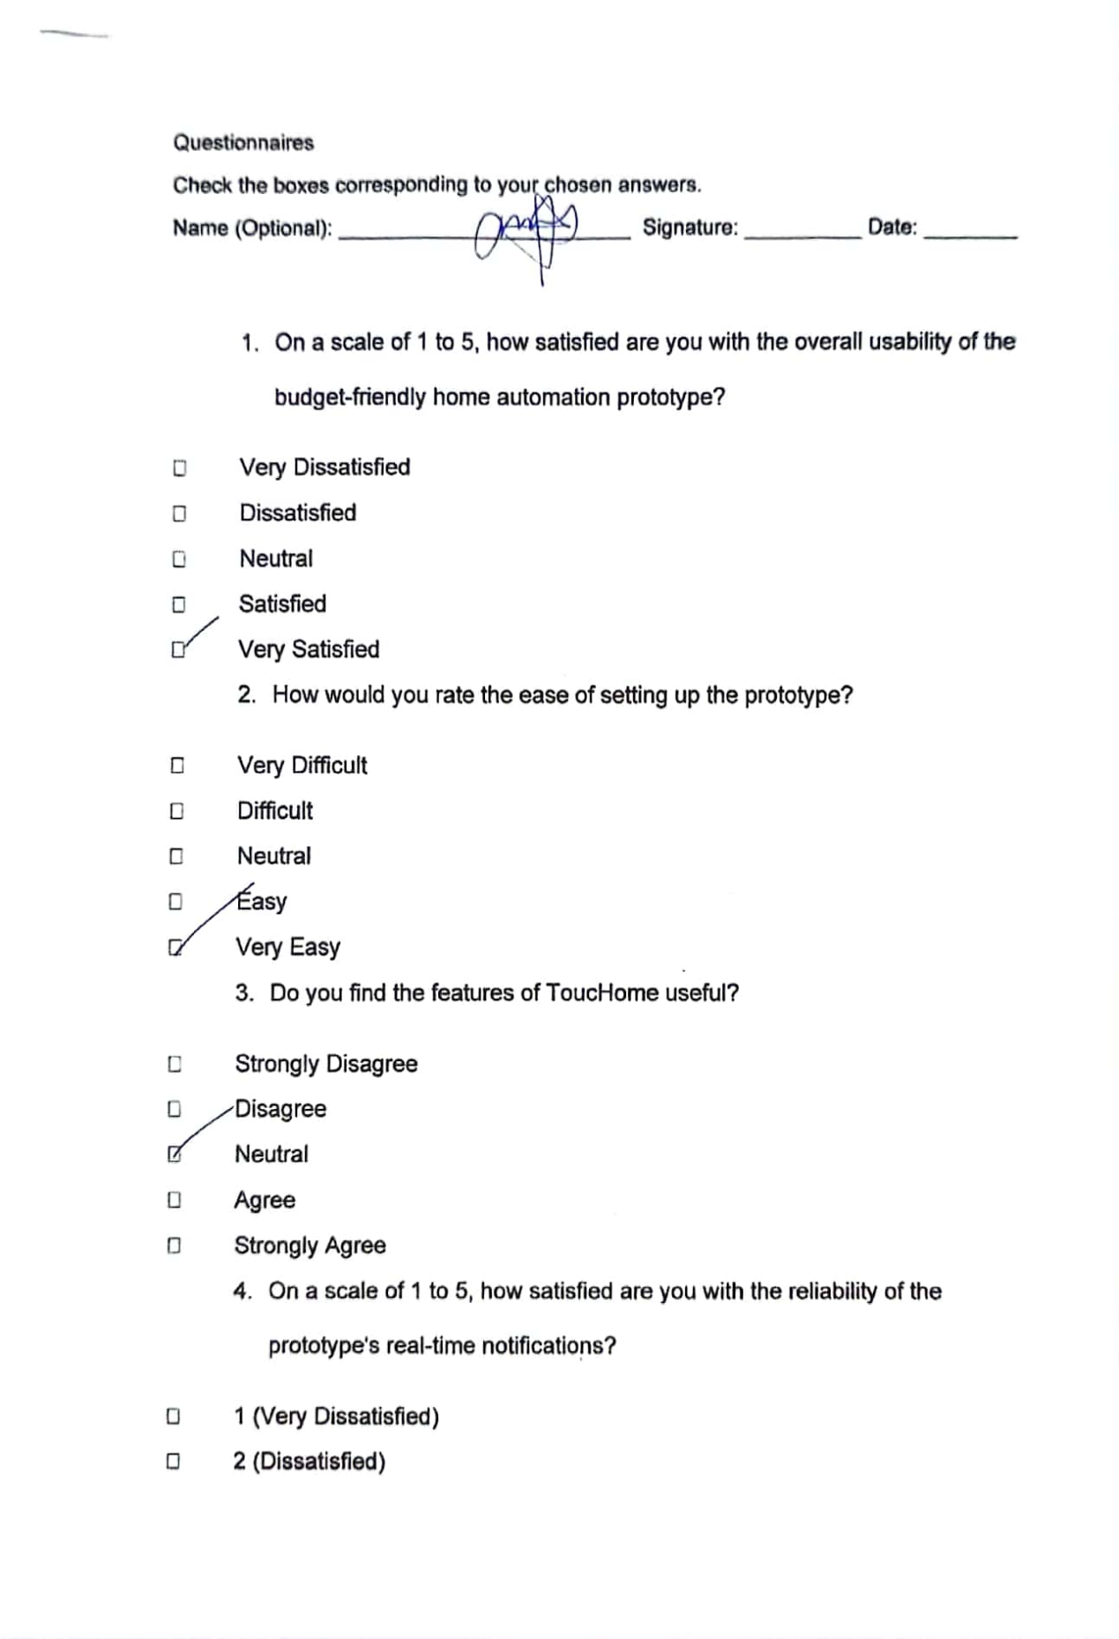

**APPENDIX A (contd.)**

**APPENDIX A (contd.)**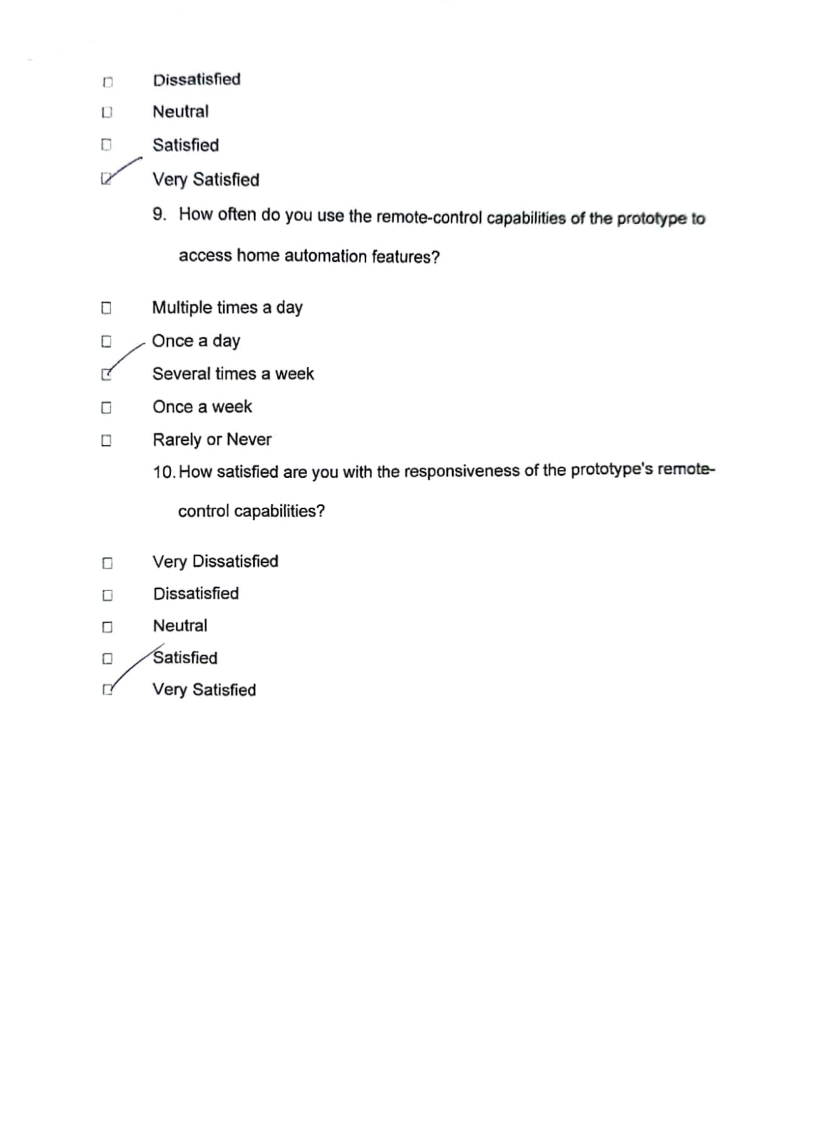

**APPENDIX A (contd.)**



**APPENDIX A (contd.)**



**APPENDIX B**

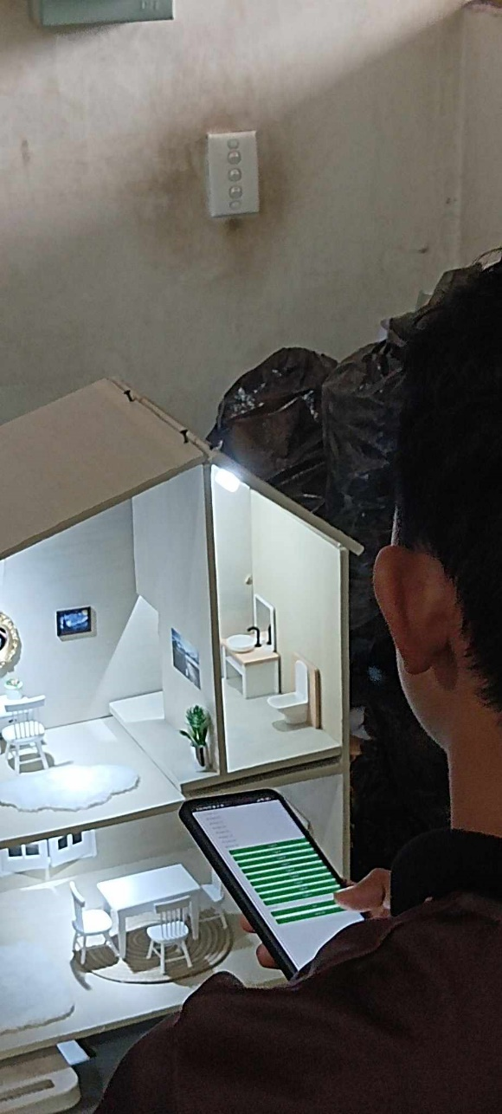**Prototype Testing & Evaluation**

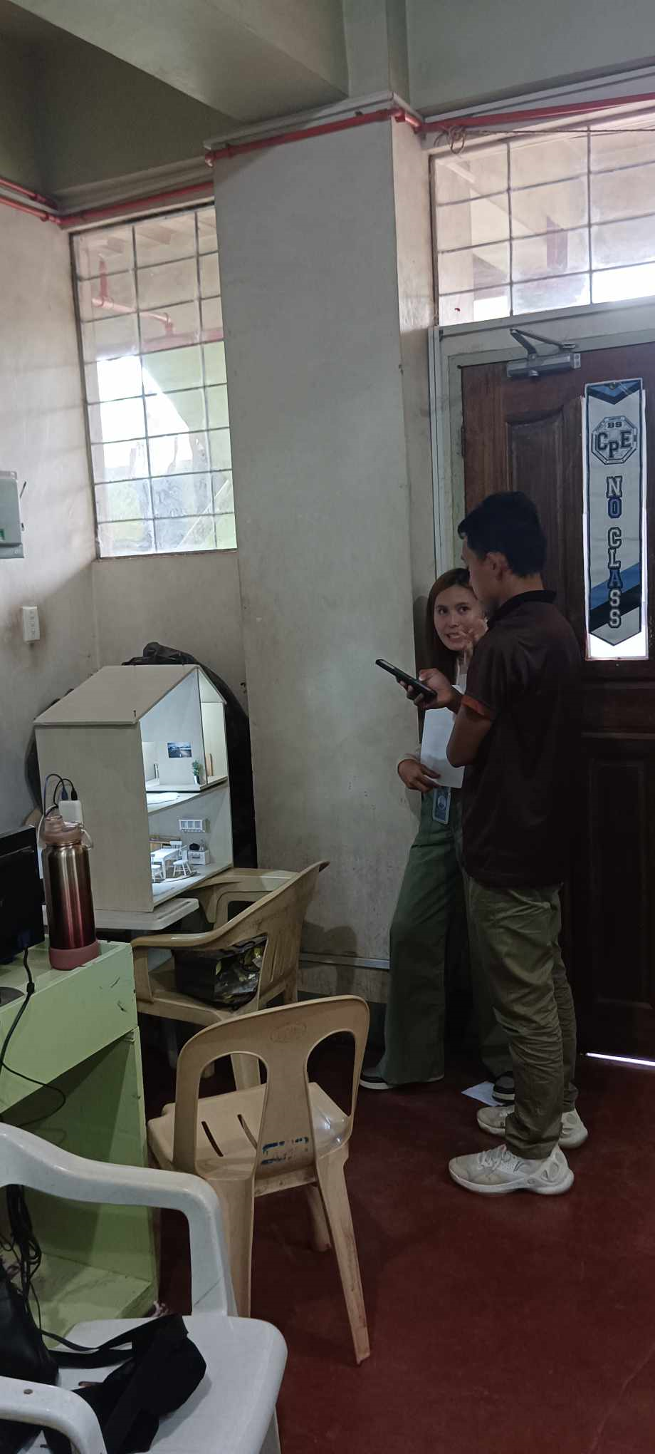

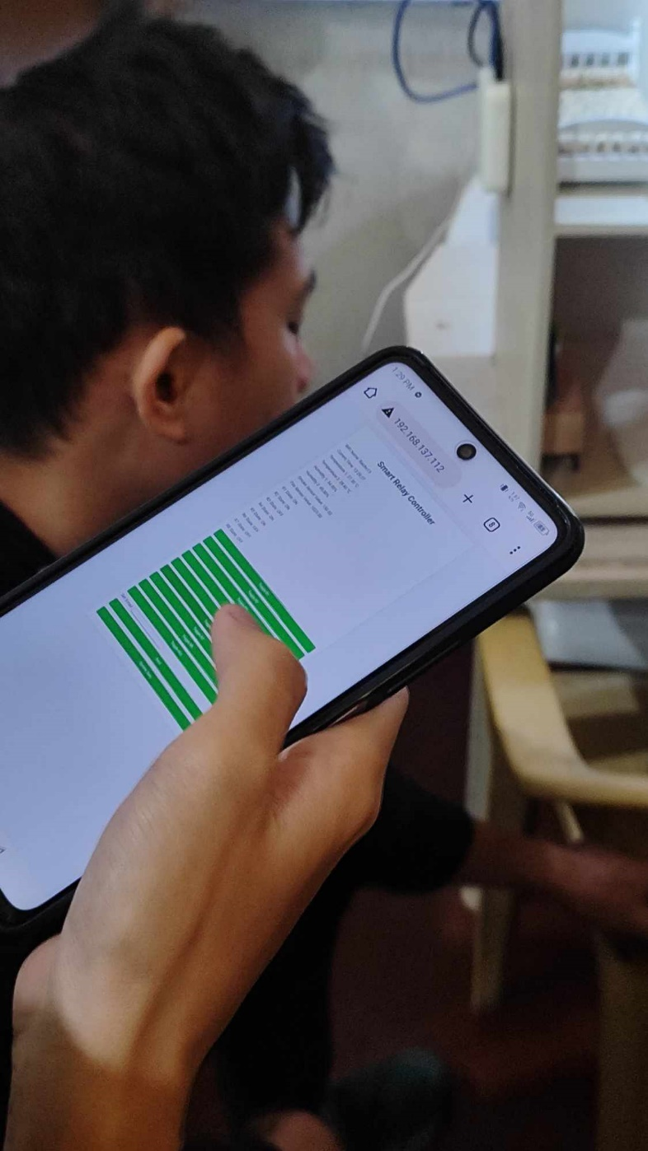**APPENDIX B (contd.)** 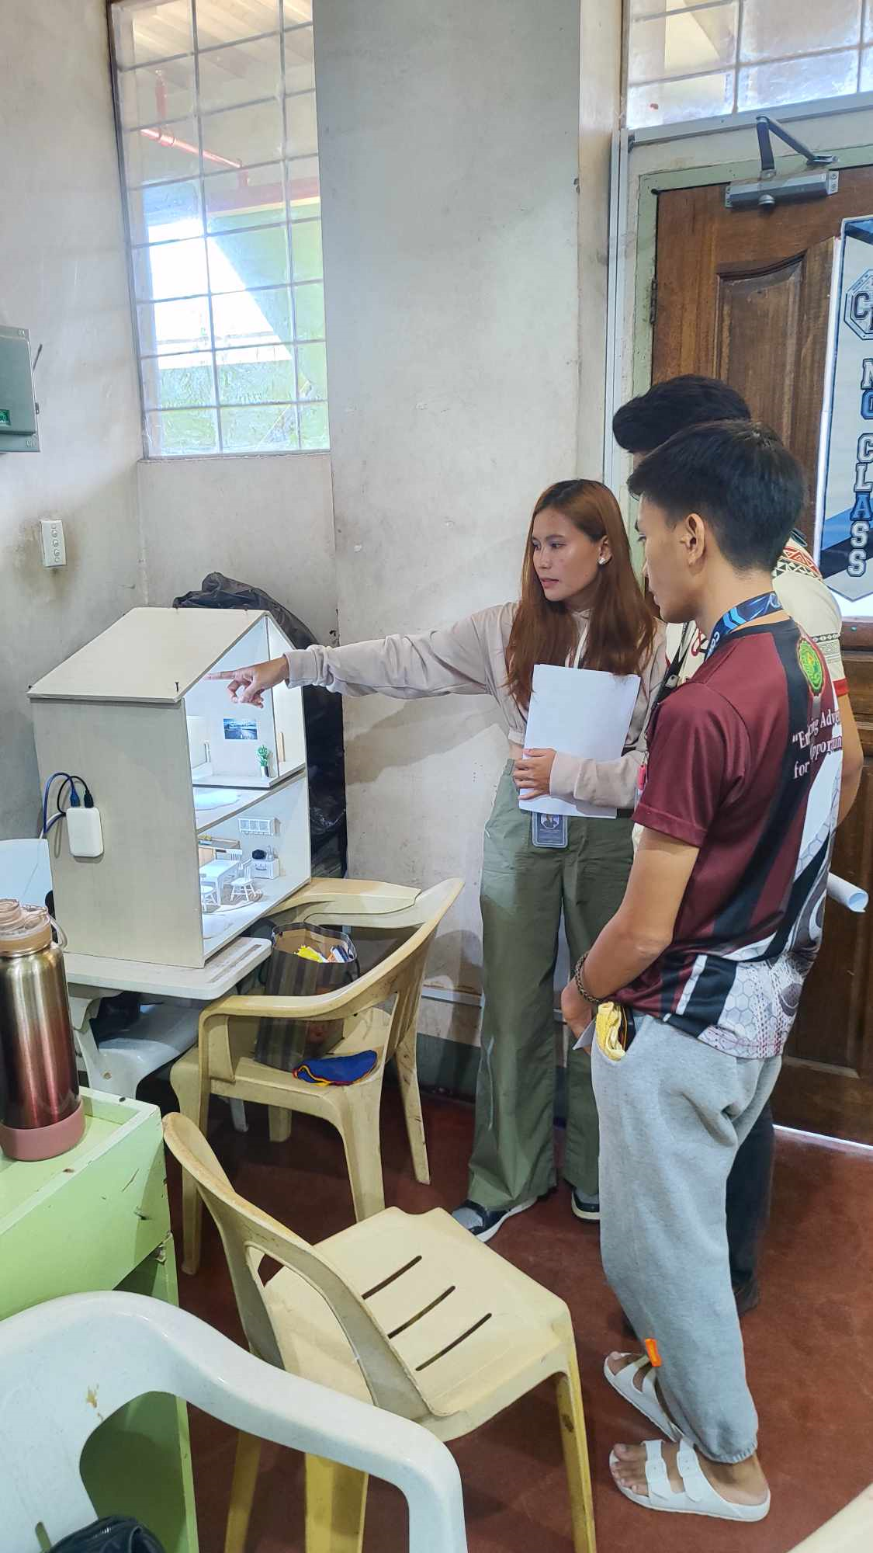

**APPENDIX C**

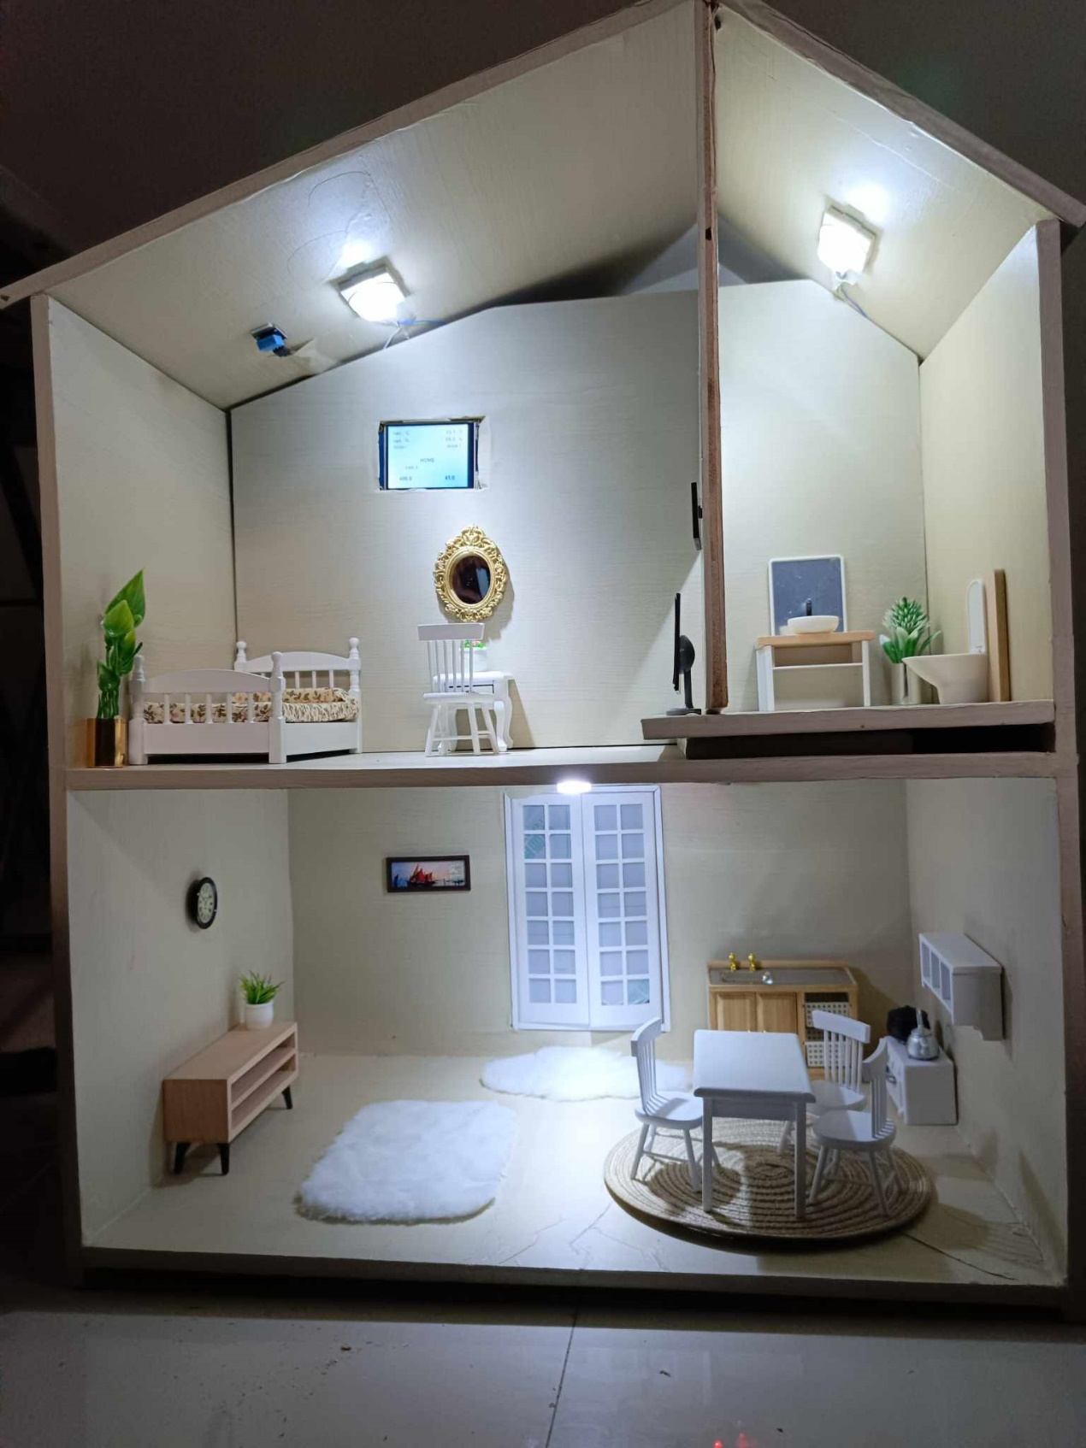**The Prototype**

**APPENDIX C (contd.)**

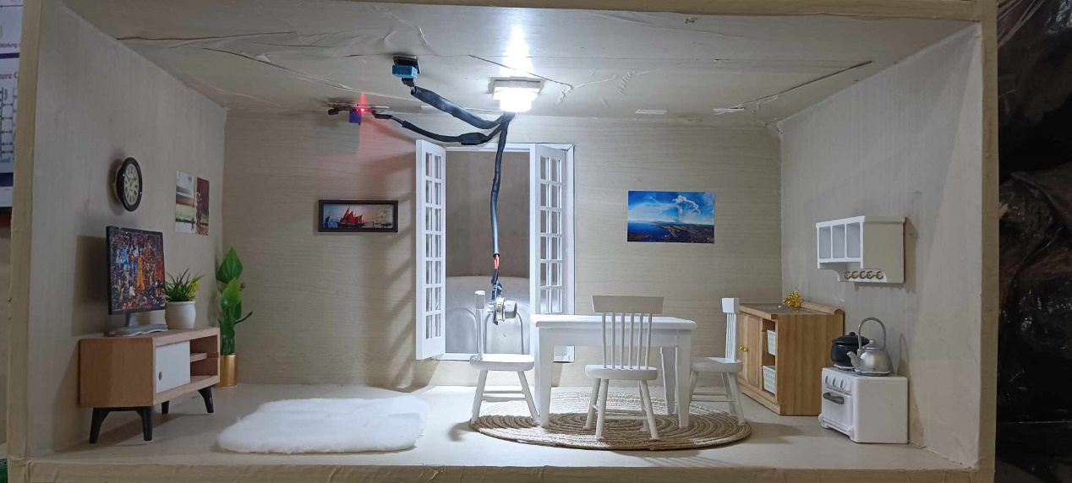

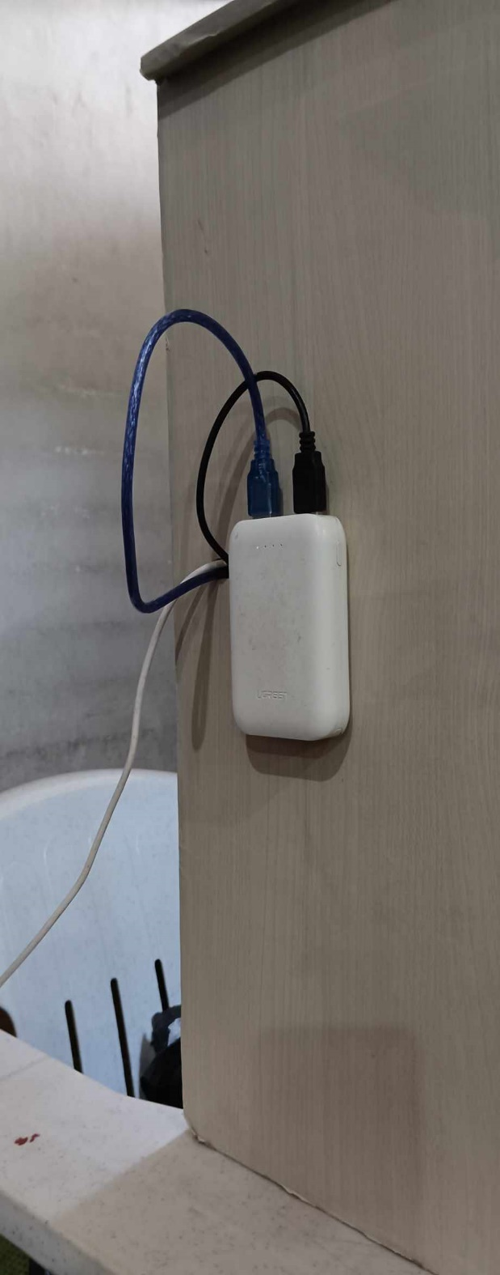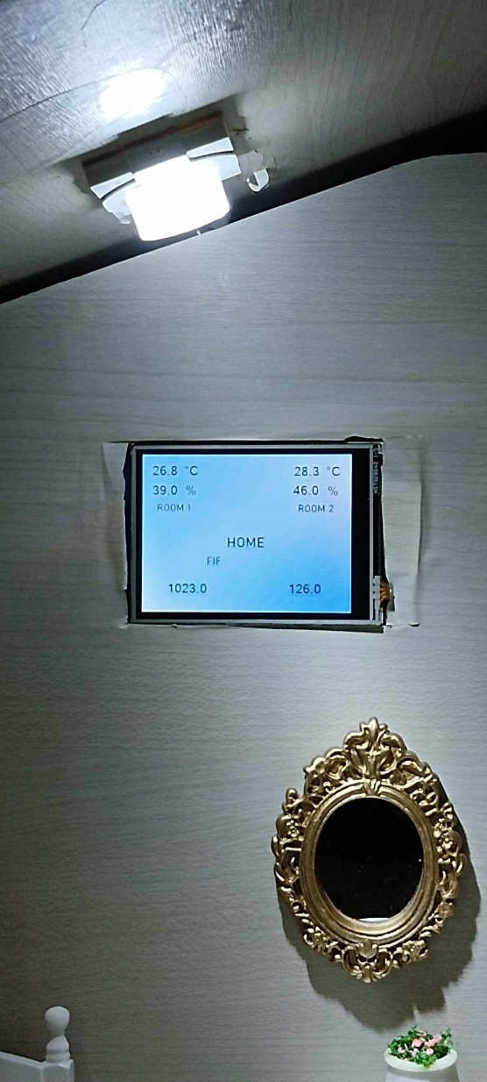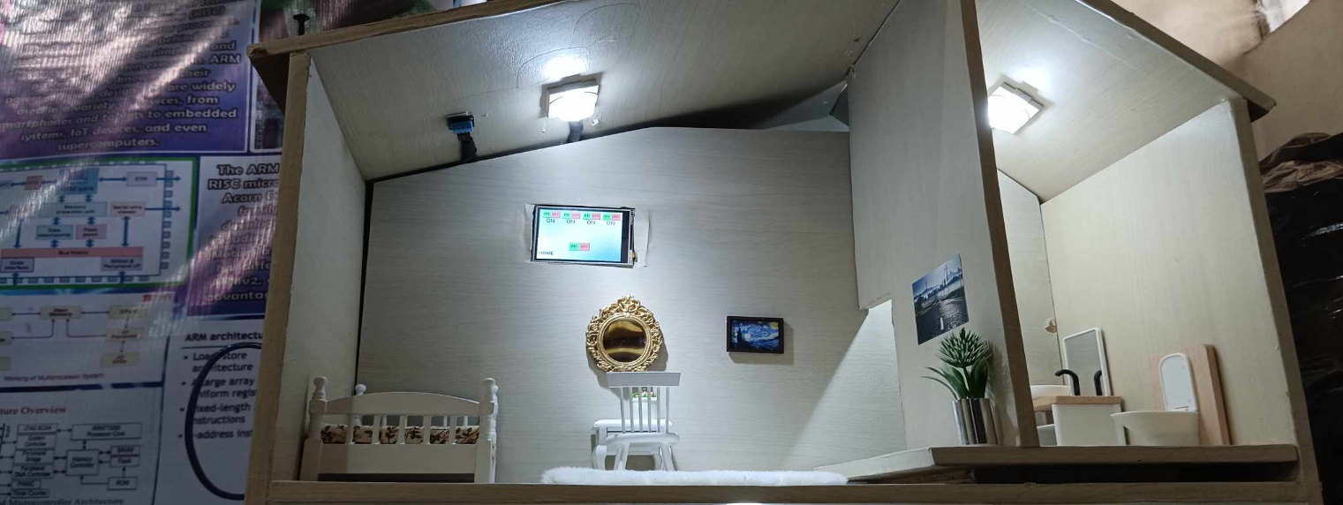

**APPENDIX D**

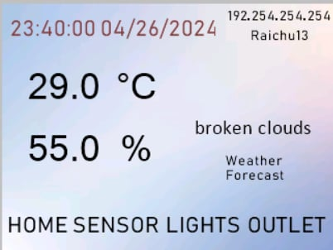Touchscreen Interface

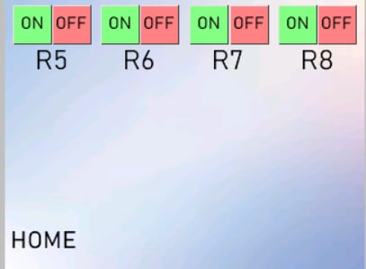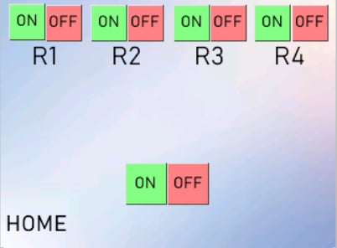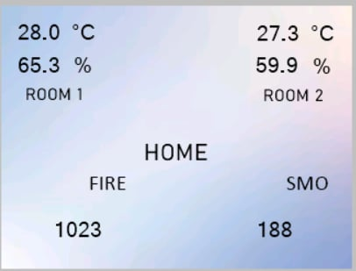

**APPENDIX E**

Online Interface

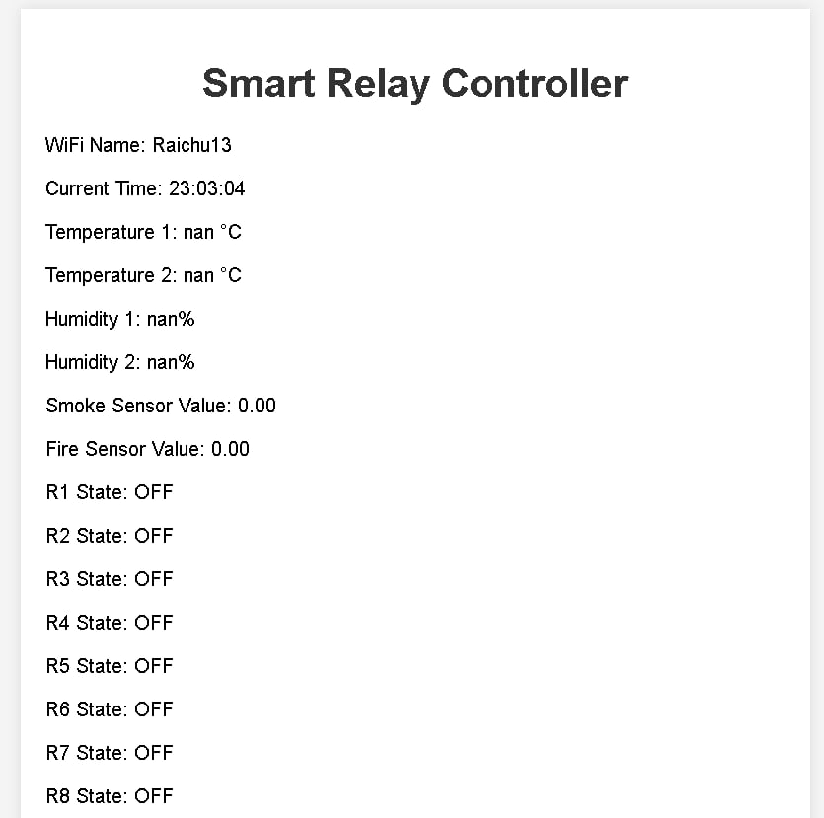

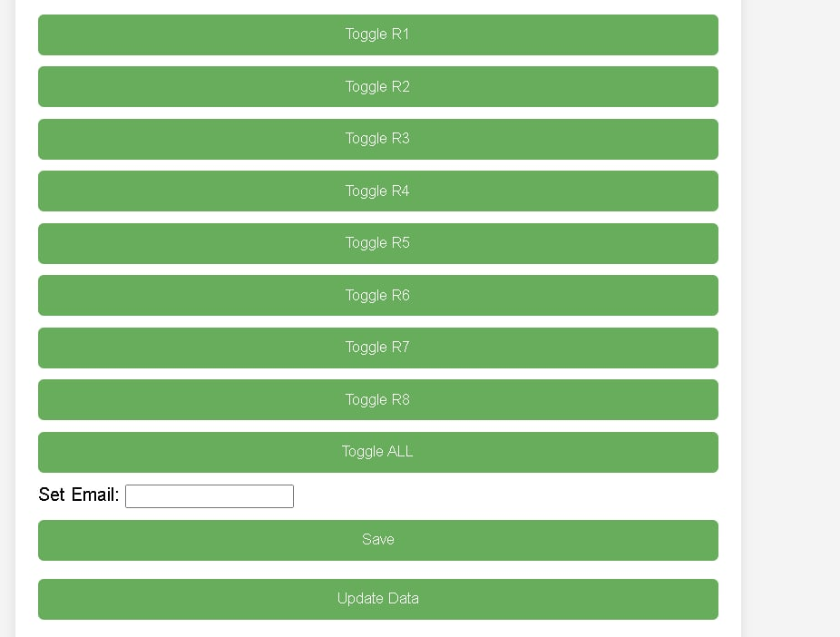

**APPENDIX F**

**Questionnaires**

**APPENDIX F (contd.)**

**APPENDIX F (contd.)**



**APPENDIX F (contd.)**

Interview Questions

**APPENDIX G**

**System Pseudocode**

// Include necessary libraries

#include <WiFi.h>

#include <NTPClient.h>

#include <WiFiUdp.h>

#include <HTTPClient.h>

#include <ArduinoJson.h>

#include <DHT.h>

#include <ESPAsyncWebServer.h>

#include <EMailSender.h>

#include <EEPROM.h>

// Define constants for email configuration

#define SMTP_EMAIL "mclaurenzgallegocaracol@gmail.com"

#define SMTP_PASSWORD "ramp fmsl wzyz ukuf"

// Global variables for sensor readings

float temp1, temp2, humidity1, humidity2, esp32FireValue, esp32SmokeValue, invertedValue;

String recipient;

// Define pin constants for sensors and relays

#define DHTPIN 2

#define DHTPIN2 18

#define SMOKE_SENSOR 34

#define FIRE_SENSOR 35

#define DHTTYPE DHT11

const int R1 = 12, R2 = 14, R3 = 27, R4 = 26, R5 = 33, R6 = 32, R7 = 19, R8 = 21;

// Define WiFi and NTP server details

const char *ssid = "Raichu13";

const char *password = "Hatdog12";

const char *ntpServer = "time.nist.gov";

// Define update time interval

const unsigned long updateTimeInterval = 1000;

unsigned long lastUpdateTime = 0;

// Define OpenWeatherMap API details

String URL = "http://api.openweathermap.org/data/2.5/weather?";

String ApiKey = "e98a1b53ba7da491c5af01a0dbc91036";

String lat = "7.857849759287383";

String lon = "123.44170183465754";

String x = "";

// Initialize DHT sensors and WiFiUDP instance for NTPClient

DHT dht1(DHTPIN, DHTTYPE);

DHT dht2(DHTPIN2, DHTTYPE);

WiFiUDP ntpUDP;

NTPClient timeClient(ntpUDP, ntpServer, 8 * 3600);

// Initialize AsyncWebServer instance

AsyncWebServer server(80);

// Setup function

void setup() {

// Initialize GPIO pins and Serial communication

pinMode(R1, OUTPUT);

pinMode(R2, OUTPUT);

pinMode(R3, OUTPUT);

pinMode(R4, OUTPUT);

pinMode(R5, OUTPUT);

pinMode(R6, OUTPUT);

pinMode(R7, OUTPUT);

pinMode(R8, OUTPUT);

Serial.begin(115200);

Serial2.begin(9600);

// Connect to WiFi and initialize NTPClient

connectToWiFi();

timeClient.begin();

dht1.begin();

dht2.begin();

EEPROM.begin(512);

// Setup routes and handlers for AsyncWebServer

setupServerRoutes();

// Begin AsyncWebServer

server.begin();

}

// Loop function

void loop() {

// Update time and sensor readings at regular intervals

unsigned long currentMillis = millis();

if (currentMillis - lastUpdateTime >= updateTimeInterval) {

updateTime();

lastUpdateTime = currentMillis;

}

// Controlling the Nextion Display

Controls();

}

// Function to connect to WiFi

void connectToWiFi() {

// Attempt to connect to WiFi

}

// Function to update time from NTP server

void updateTime() {

// Update time from NTP server

// Update Nextion display with time, date, and weather forecast

}

Controls() {

// Check if there is data available to read from Serial2

if (Serial2.available() > 0) {

// Read the incoming data until a newline character is encountered

x = Serial2.readStringUntil('\n');

// Print the received data to the Serial monitor

Serial.print("Received: ");

Serial.println(x);

// Check the received data and perform relay manipulations based on specific conditions

if (x == "ON") {

// Turn on relay R1 and update its status

digitalWrite(R1, HIGH);

updateR1("ON");

} else if (x == "OFF") {

// Turn off relay R1 and update its status

digitalWrite(R1, LOW);

updateR1("OFF");

}

// Similar conditions for other relays (R2 to R8) and main control

}

}

// Function to update Nextion display with sensor data

void updateNextionDisplay() {

// Update Nextion display with sensor data

}

// Function to send email notifications

void sendEmailNotification(String subject, String message) {

// Send email notifications using EMailSender library

}

# CURRICULUM VITAE

**BRETTNEY SHANE M. FRANCISCO**

|  |  |
| --- | --- |
| Permanent Address | : Purok Tejada, Upper Sibatang, Pagadian City,  Zamboanga del Sur |
| Home Address | : Purok Tejada, Upper Sibatang, Pagadian City,  Zamboanga del Sur |
| Contact Number | : 09382068449 |
| e-mail Address | : brettneyfrancisco112101@gmail.com |
|  |  |
| **PERSONAL INFORMATION** | |
|  | |
| Date of Birth | : November 21, 2001 |
| Place of Birth | : Sebucao, Dumalinao, Zamboanga del Sur |
| Height | : 168 cm |
| Weight | : 48 kls |
| Civil Status | : Single |
| Father | : Gilbert L. Francisco |
| Mother | : Eva M. Francisco |
|  |  |
| **EDUCATIONAL BACKGROUND** | |
|  |  |
| Elementary | : Galas Elementary School |
| Secondary | : Dumalinao National High School |
| Tertiary | : Southern Mindanao Colleges |
|  |  |
| **SPECIAL SKILLS** | |
|  | |
| Communication Skills – I can express myself clearly and confidently, both verbally and in writing. | |
|  | |
|  | |

**CURRICULUM VITAE**

**MC LAURENZ G. CARACOL**

|  |  |  |
| --- | --- | --- |
| Permanent Address | : | Vetallea Highland Homes, Manga Pagadian City |
| Home Address | : | Vetallea Highland Homes, Manga Pagadian City |
| Contact Number | : | 09923549674 / 09631348826 |
| e-mail Address | : | mclaurenzgallegocaracol@gmail.com |
|  |  |  |
| **PERSONAL INFORMATION** | | |
|  | | |
| Date of Birth | : | May 13, 2002 |
| Place of Birth | : | Pagadian City |
| Height | : | 162 cm |
| Weight | : | 65 kg |
| Civil Status | : | Single |
| Father | : | Rosito Quimno Caracol |
| Mother | : | Rosana Castor Gallego |
|  |  |  |
| **EDUCATIONAL BACKGROUND** | | |
|  |  |  |
| Elementary | : | Tuburan Central Elementary School |
| Secondary | : | Zamboanga Del Sur National High School |
| Tertiary | : | Southern Mindanao Colleges |
|  |  |  |
| **SPECIAL SKILLS** | | |
|  |  |  |
| C++, Technical and Analytical Skills, Computer Literate | | |
|  |  |  |
|  |  |  |

**CURRICULUM VITAE**

**NADZJAR S. ARSAD**

|  |  |  |
| --- | --- | --- |
| Permanent Address | : | Saloagan, Dimataling, Zamboanga del Sur |
| Home Address | : | Purok 2, Saloagan, Dimataling, Zamboanga del Sur |
| Contact Number | : | 09709610164/09668797287 |
| e-mail Address | : | nadzarsadsacaludan@gmail.com |
|  |  |  |
| **PERSONAL INFORMATION** | | |
|  | | |
| Date of Birth | : | July 29, 2001 |
| Place of Birth | : | Saloagan, Dimataling, Zamboanga del Sur |
| Height | : | 5’6ft/152 cm |
| Weight | : | 60 kg |
| Civil Status | : | Single |
| Father | : | Yamanie Arsad |
| Mother | : | Parida Arsad |
|  |  |  |
| **EDUCATIONAL BACKGROUND** | | |
|  |  |  |
| Elementary | : | Saloagan Elementary School |
| Secondary | : | Saloagan National High School |
| Tertiary | : | Southern Mindanao Colleges |
|  |  |  |
| **SPECIAL SKILLS** | | |
|  |  |  |
| None | | |
|  |  |  |
|  |  |  |

**CURRICULUM VITAE**

**ROKC B. BALAN**

|  |  |  |
| --- | --- | --- |
| Permanent Address | : | Purok Gemilina, Barangay Buenavista, Pagadian City, Zamboanga Del Sur, Philippines, 7016 |
| Home Address | : | Purok Gemilina, Barangay Buenavista, Pagadian City, Zamboanga Del Sur, Philippines, 7016 |
| Contact Number | : | 09614577459 |
| e-mail Address | : | balanrokc@gmail.com |
|  |  |  |
| **PERSONAL INFORMATION** | | |
|  | | |
| Date of Birth | : | February 12, 1998 |
| Place of Birth | : | Pagadian City |
| Height | : | 5 feet and 1 inches (5’1) |
| Weight | : | 65 kilograms |
| Civil Status | : | Single |
| Father | : | Mr. Rosalito Jabian Balan (Deceased) |
| Mother | : | Mr. Cresencia Bontilao Balan |
|  |  |  |
| **EDUCATIONAL BACKGROUND** | | |
|  |  |  |
| Elementary | : | Balangasan Central Elementary School |
| Secondary | : | Zamboanga Del Sur School of Arts and Trades |
| Tertiary | : | Southern Mindanao Colleges |
|  |  |  |
| **SPECIAL SKILLS** | | |
| Computer Programming |  | Programming Languages: VB.NET |
| Languages |  | Fluent in English |

**CURRICULUM VITAE**

**MICHAEL H. PETALLAR**

|  |  |  |
| --- | --- | --- |
| Permanent Address | : | Prk. Panaghiusa, Dumalinao, Zamboanga Del Sur |
| Home Address | : | Prk. Panaghiusa, Dumalinao, Zamboanga Del Sur |
| Contact Number | : | 09095024489 |
| e-mail Address | : | Michaelpets14@gmail.com |
|  |  |  |
| **PERSONAL INFORMATION** | | |
|  | | |
| Date of Birth | : | February 14, 1986 |
| Place of Birth | : | Pagadian City |
| Height | : | 5’4 |
| Weight | : | 64 kilograms |
| Civil Status | : | Married |
| Father | : | Andrew M. Petallar |
| Mother | : | Teodora T. Petallar |
|  |  |  |
| **EDUCATIONAL BACKGROUND** | | |
|  |  |  |
| Elementary | : | Balangasan Central Elementary School |
| Secondary | : | Pagadian City National Comprehensive High School |
| Tertiary | : | Saint Columban College / Southern Mindanao Colleges |
|  |  |  |
| **SPECIAL SKILLS** | | |
| Dancing, Singing & Driving |  |
|  |  |
|  |  |  |

# CURRICULUM VITAE

**Kenechi A. Palabrica**

|  |  |  |
| --- | --- | --- |
| Permanent Address | : | Purok Rubia, Barangay San Franciso, Pagadian City, Zamboanga Del Sur, Philippines, 7016 |
| Home Address | : | Purok Rubia, Barangay San Franciso, Pagadian City, Zamboanga Del Sur, Philippines, 7016 |
| Contact Number | : | 09667601703 |
| e-mail Address | : | Kpalabrica2001@gmail.com |
|  |  |  |
| **PERSONAL INFORMATION** | | |
|  | | |
| Date of Birth | : | August, 15, 2001 |
| Place of Birth | : | Pagadian City |
| Height | : | 5’6 |
| Weight | : | 65 kilograms |
| Civil Status | : | Single |
| Father | : | Peter T. Palabrica (Deceased) |
| Mother | : | Buenaluz A. Palabrica |
|  |  |  |
| **EDUCATIONAL BACKGROUND** | | |
|  |  |  |
| Elementary | : | Southern Mindanao Colleges |
| Secondary | : | Southern Mindanao Colleges |
| Tertiary | : | Southern Mindanao Colleges |
|  |  |  |
| **SPECIAL SKILLS** | | |
| Computer Technician |  |  |
| Welding (Smaw) |  | Metal fabrications |
| Photography |  | Freelance photographer |
| Motorcycle Mechanic |  | Small engine mechanic specialized in scooter |